AZURE ADMINISTRATOR LAB

Resource Group Deployement
I created my first Azure Resource Group named RG-AZ104-LAB in the Canada Central region using my Azure subscription. This Resource Group will serve as the central container for all Azure resources I deploy throughout my AZ-104 preparation, including virtual machines, virtual networks, storage accounts, monitoring resources, and identity management labs. I also learned how Azure organizes cloud resources into logical groups for easier administration, access control, cost management, and lifecycle management. 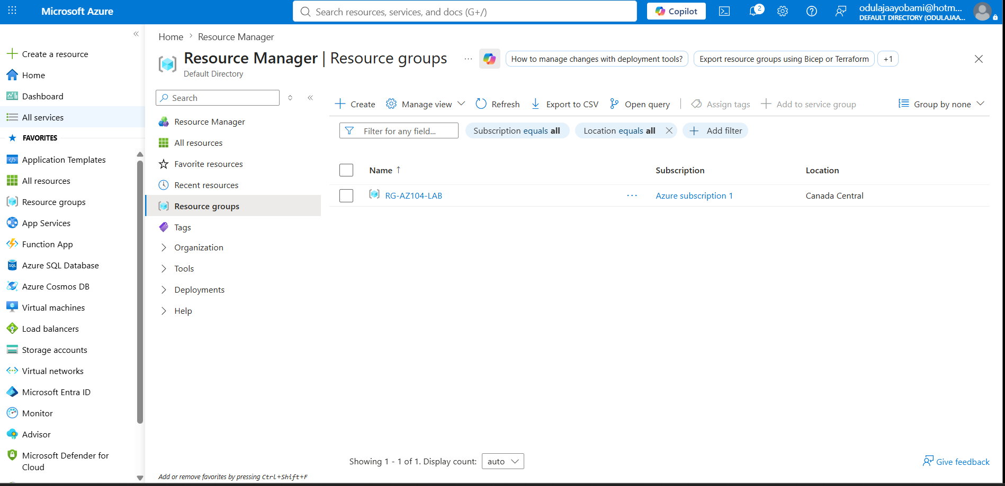

Creating a storage accout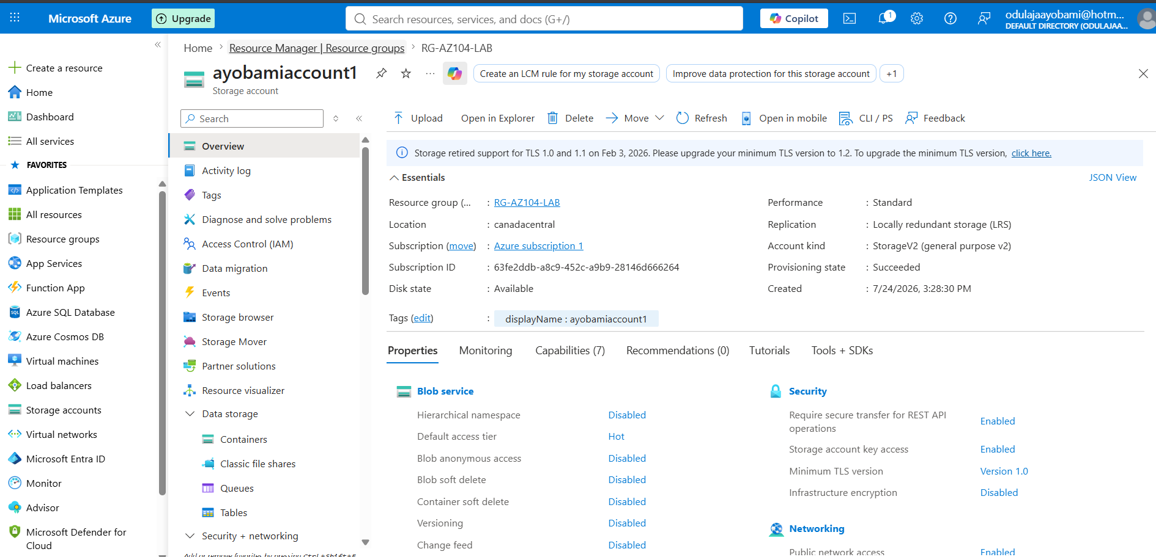

I enhanced the ARM template by parameterizing the storage account SKU. Rather than hardcoding the SKU, I defined a storageSKU parameter with a default value and a list of allowed values. I updated the resource definition to reference this parameter, enabling the same template to deploy storage accounts with different redundancy options without modifying the template itself. I successfully validated the deployment using an approved SKU and confirmed that ARM enforces input validation by rejecting unsupported values. 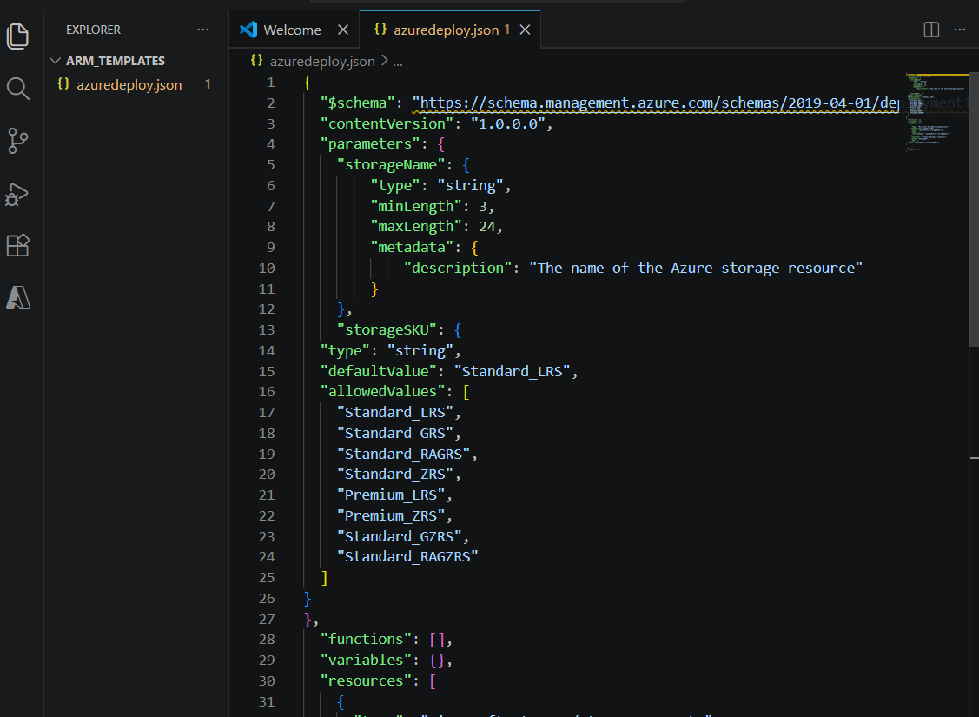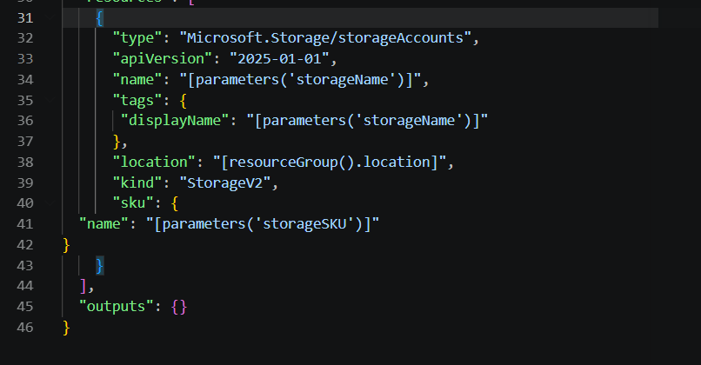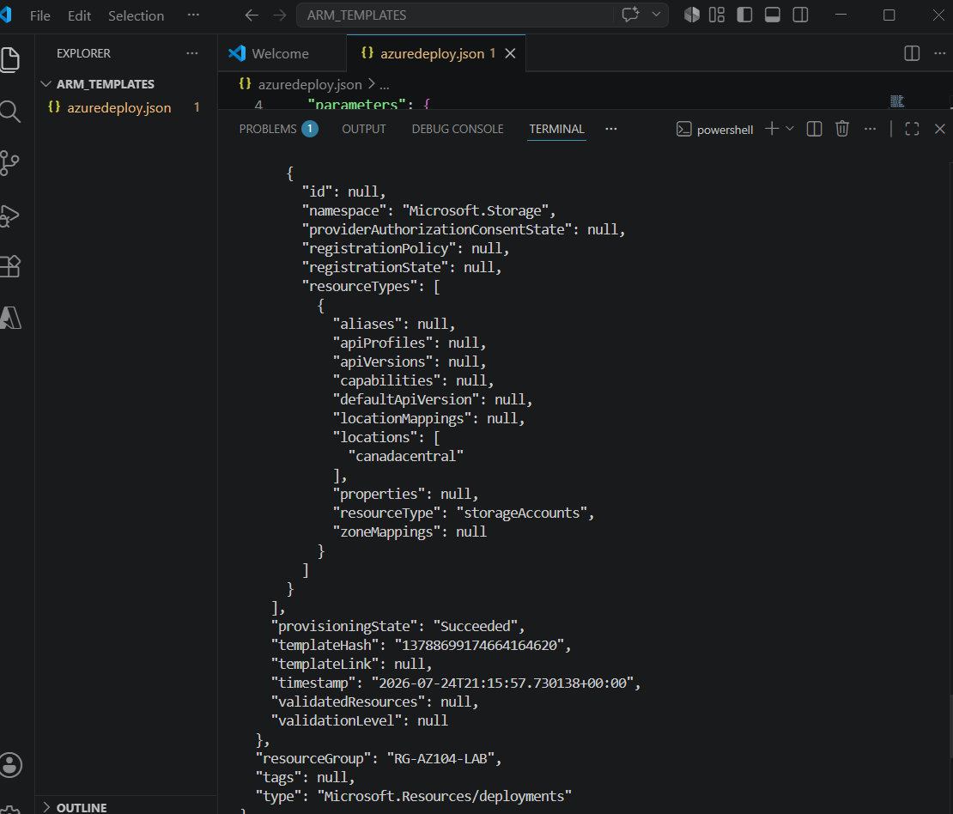

I successfully deployed the template using a valid SKU (Standard_GRS) and then intentionally attempted a deployment with an invalid value (Basic). ARM template validation correctly rejected the deployment before any Azure resources were modified, demonstrating how input validation enforces deployment standards and prevents configuration errors. 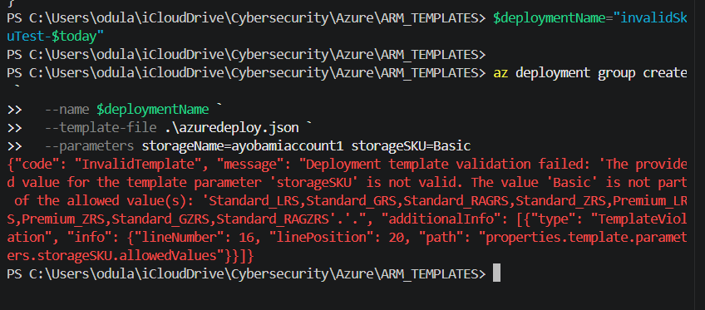

I successfully deployed an Azure Storage Account multiple times, demonstrated ARM's idempotent behavior, validated template parameters through both successful and failed deployments, and used the reference() function to return the storage account's primary service endpoints after deployment. 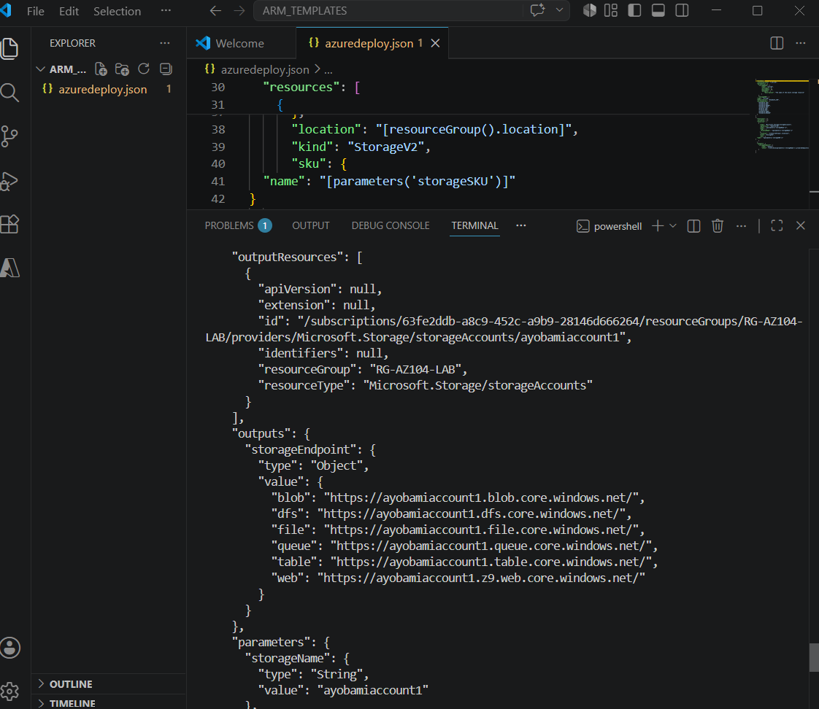

Creating A new User
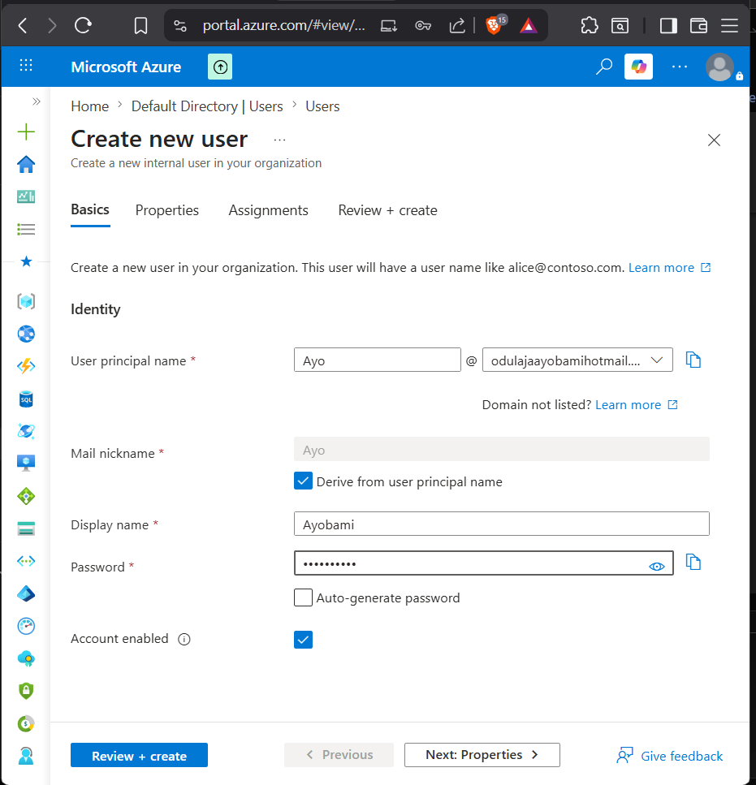

Creating a new group 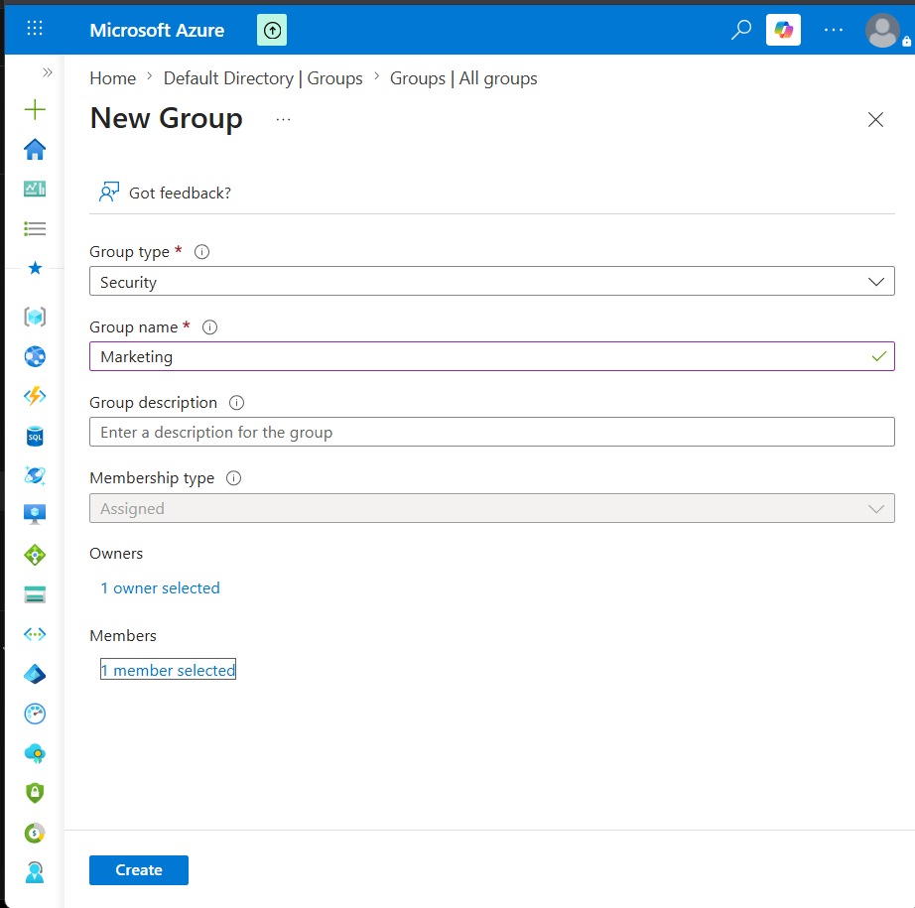

Deleting User 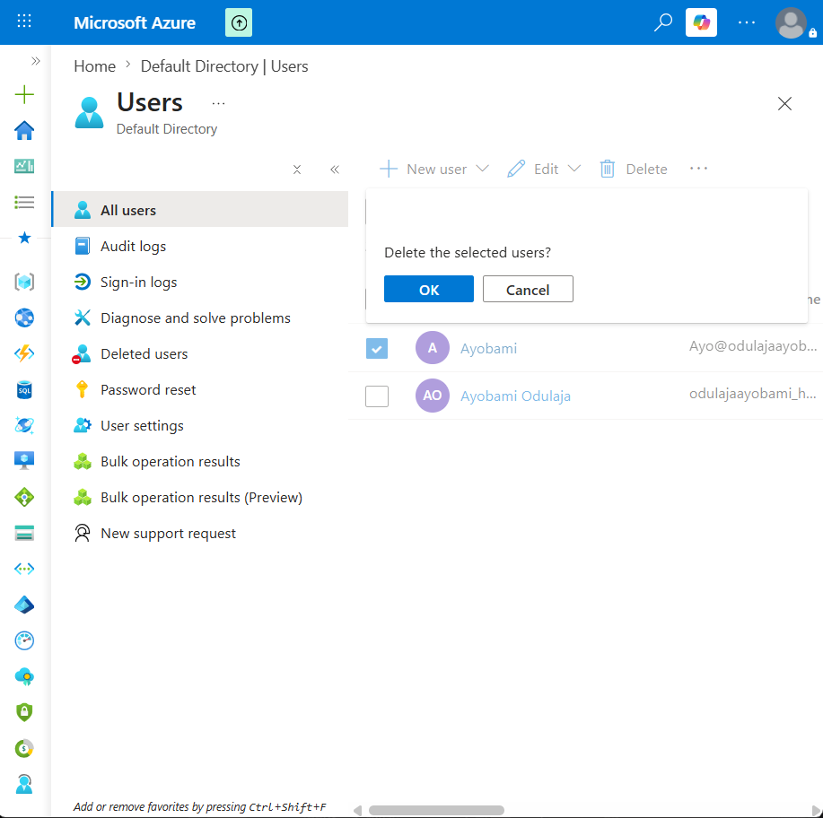

Restoring user that was deleted 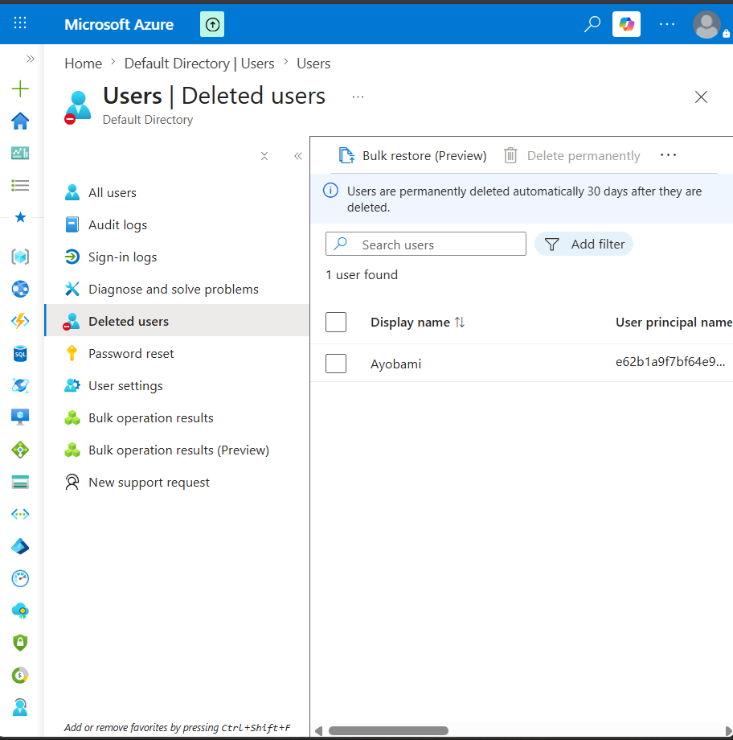 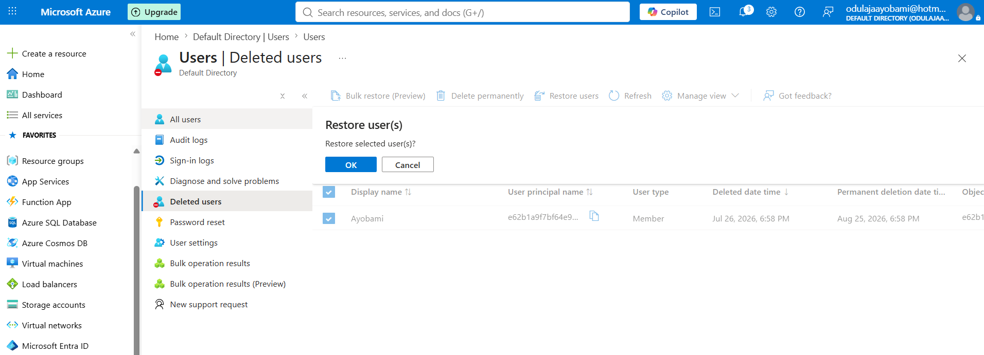

Creating a Microsoft 365 group type 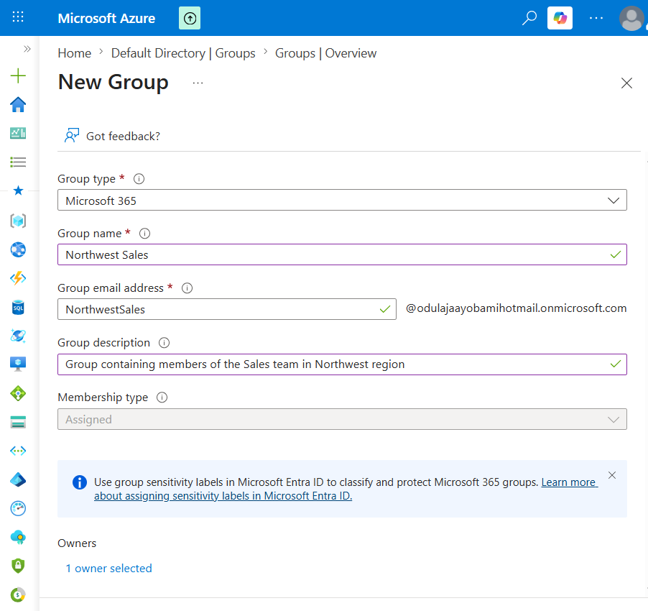

VIEWING PERMISSION FROM MY PROFILE 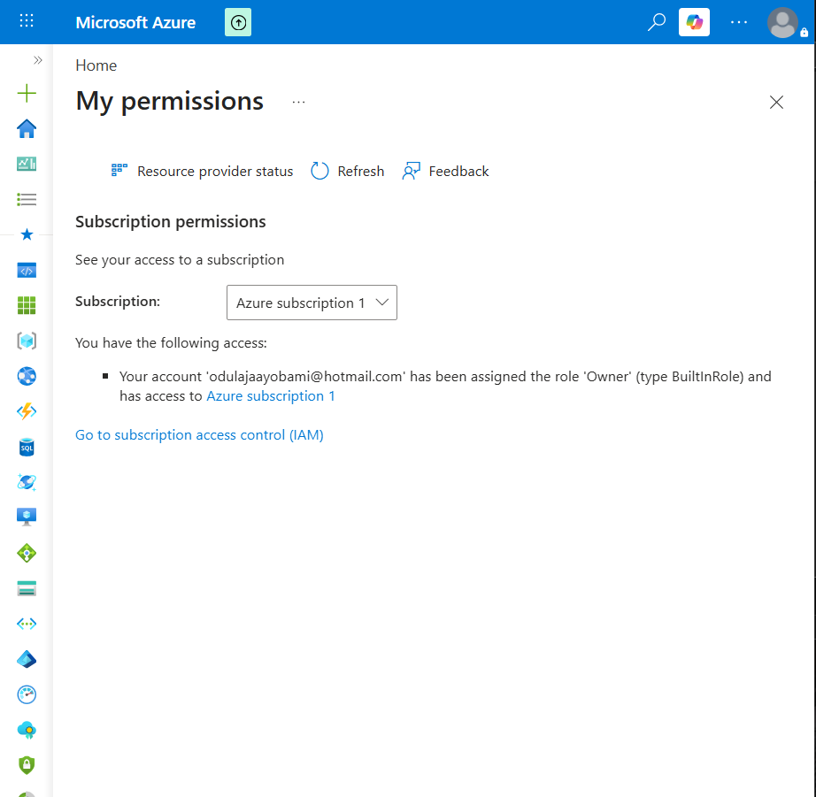

Role Assignment: 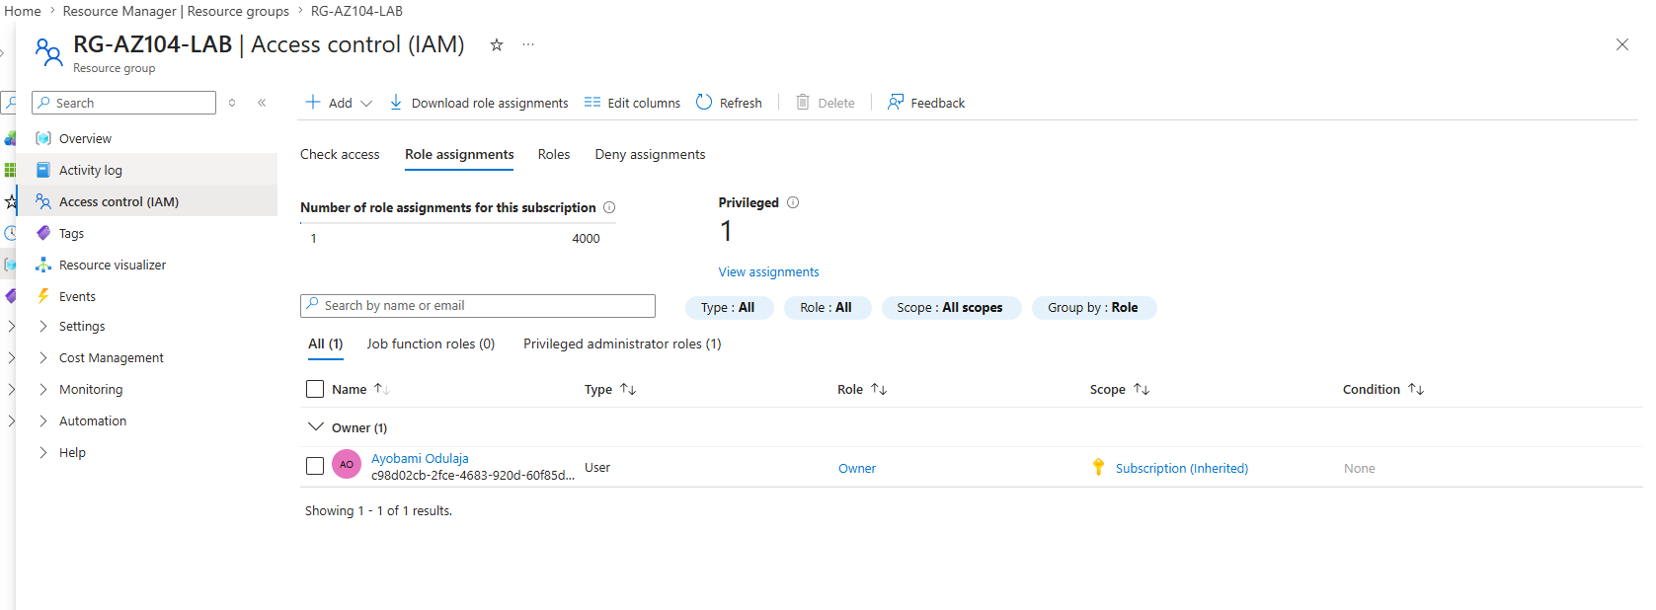

Roles 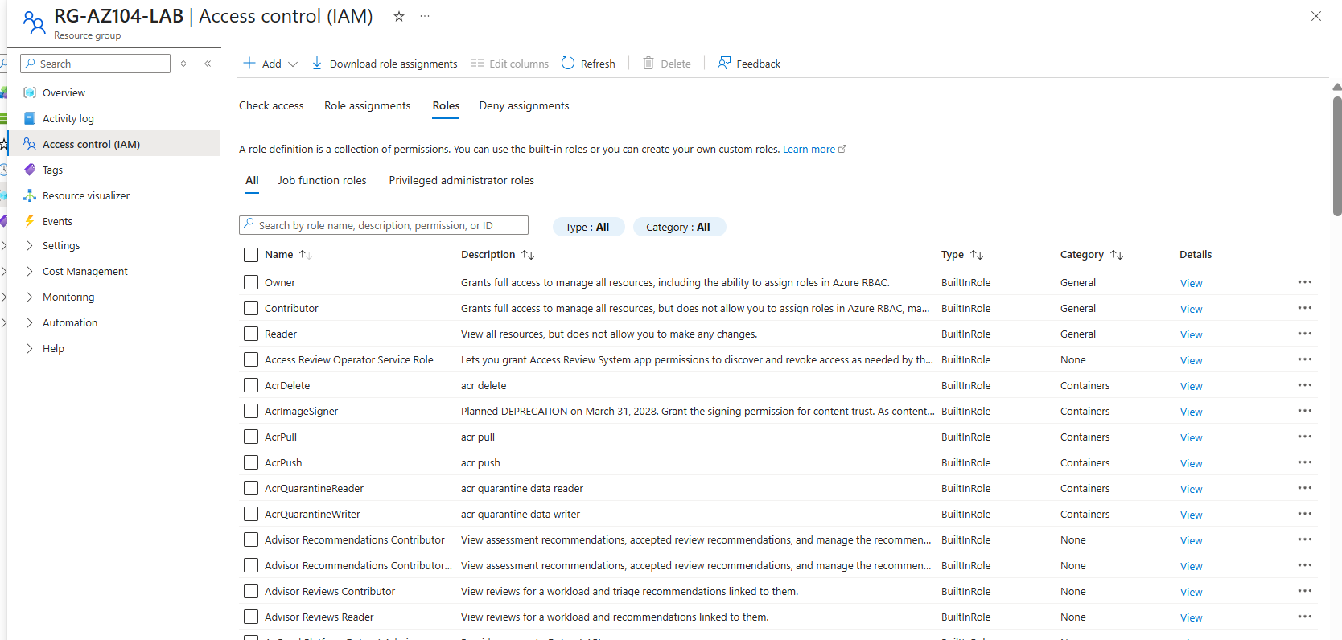

Add Role Assignment: 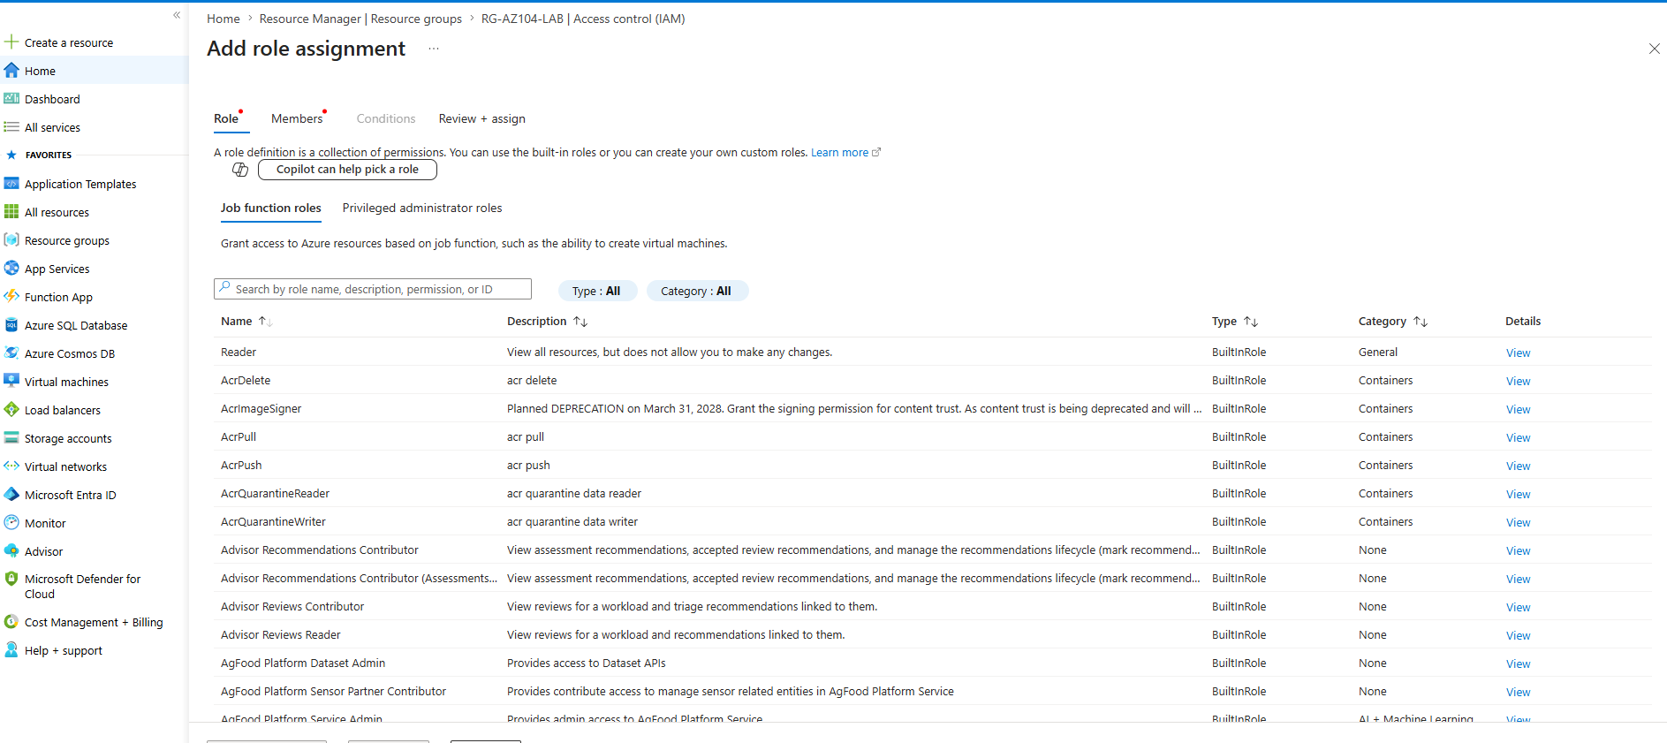

Grant access using Azure RBAC and Azure portal:
- First I want to create a test user: 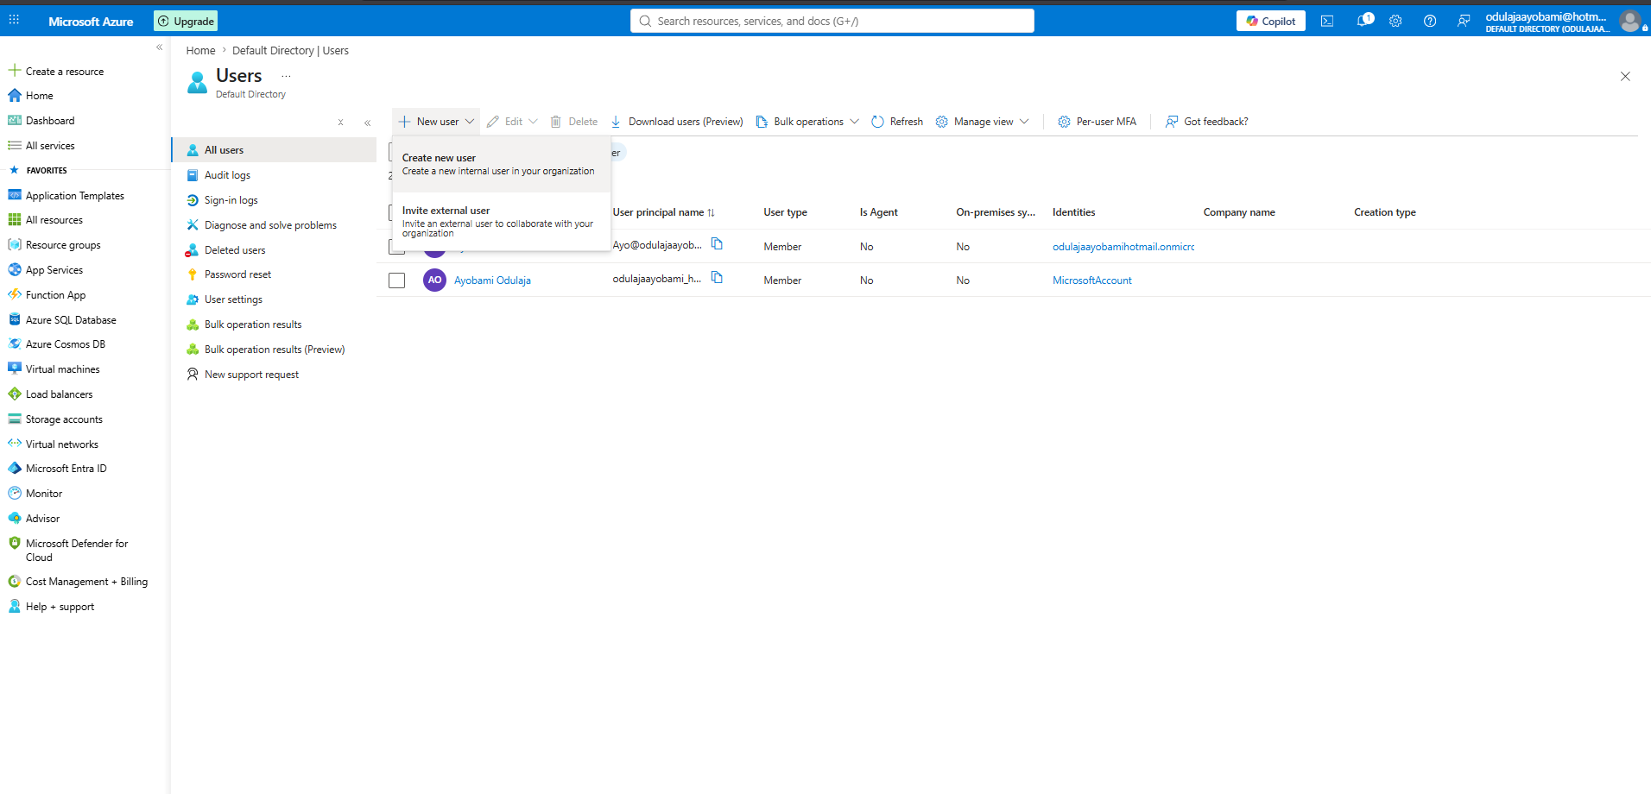 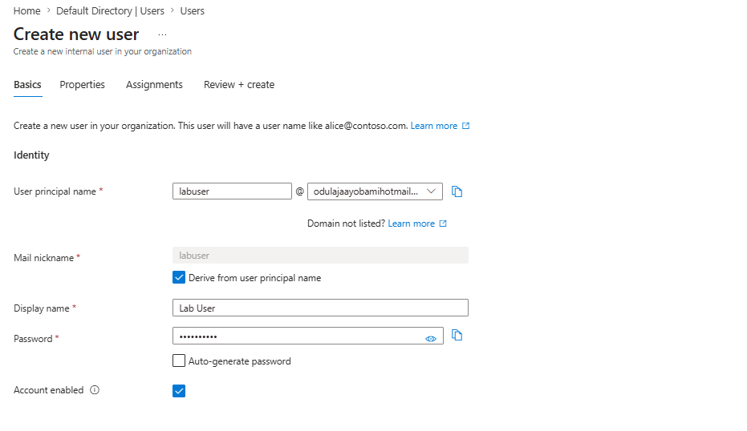 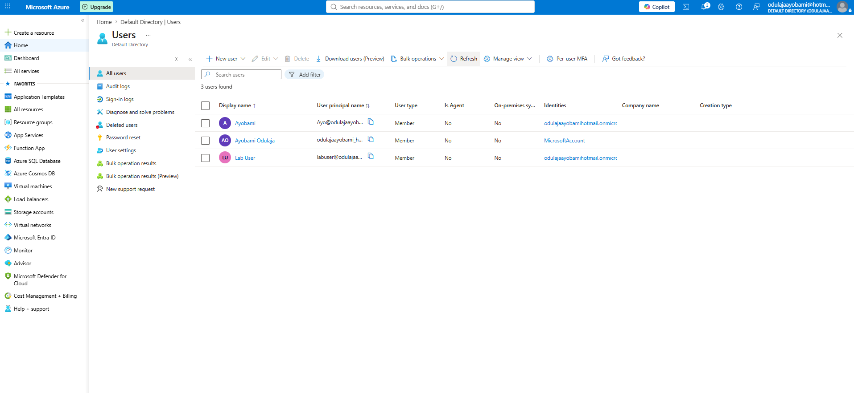

Give Lab User Access to Resources:
Assigning user as a virtual machine contributor: 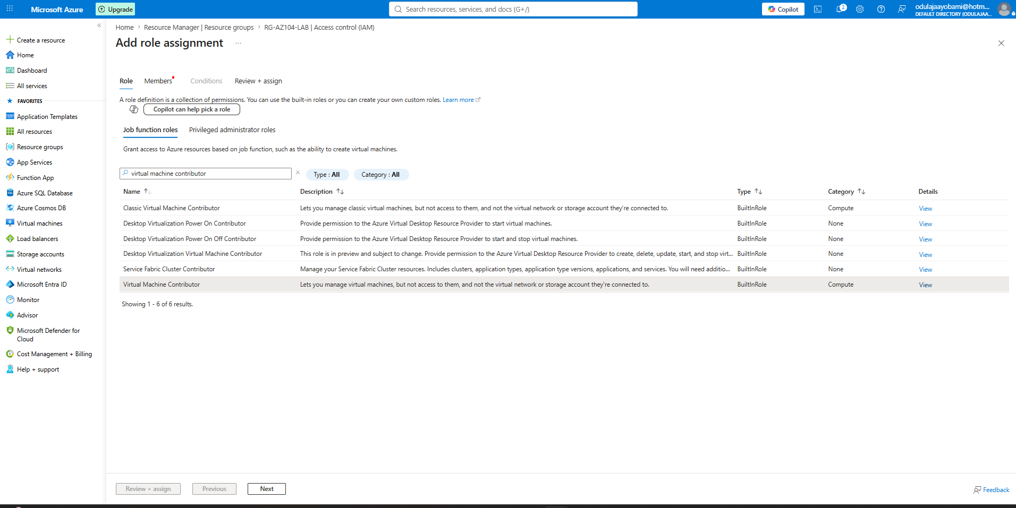 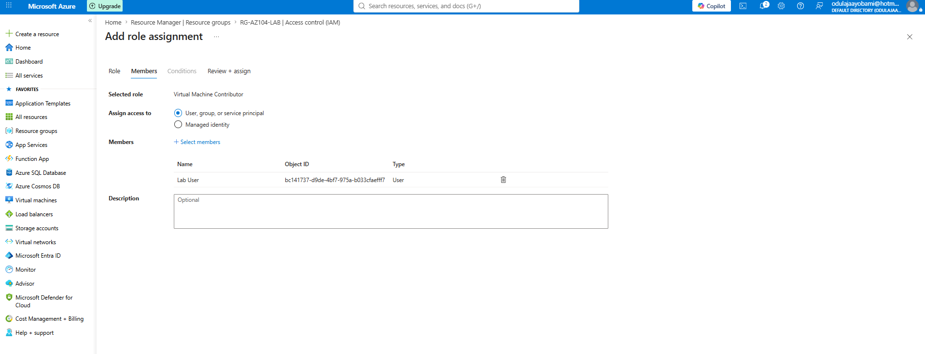

Confirming Role Assignment 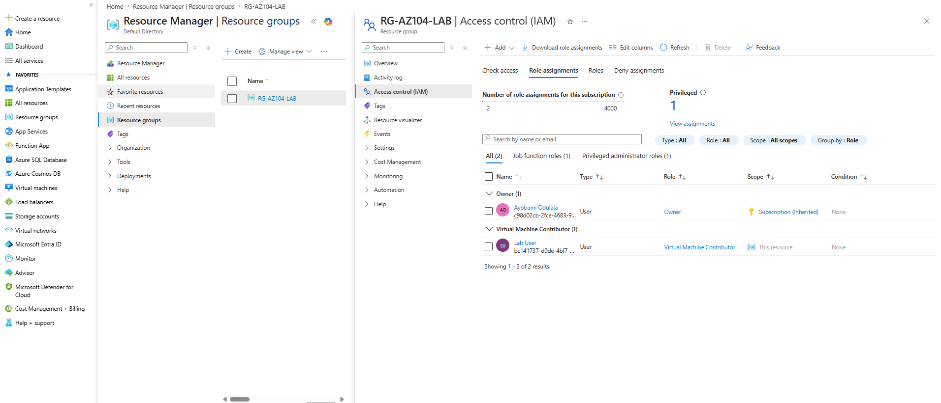

Viewing activity Log 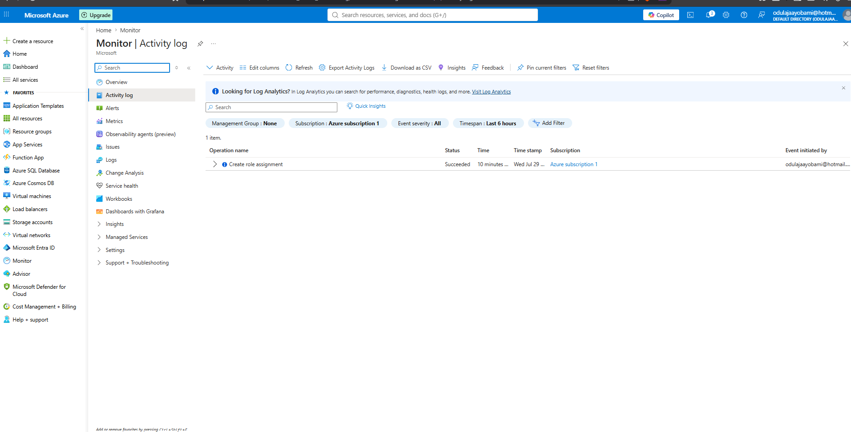 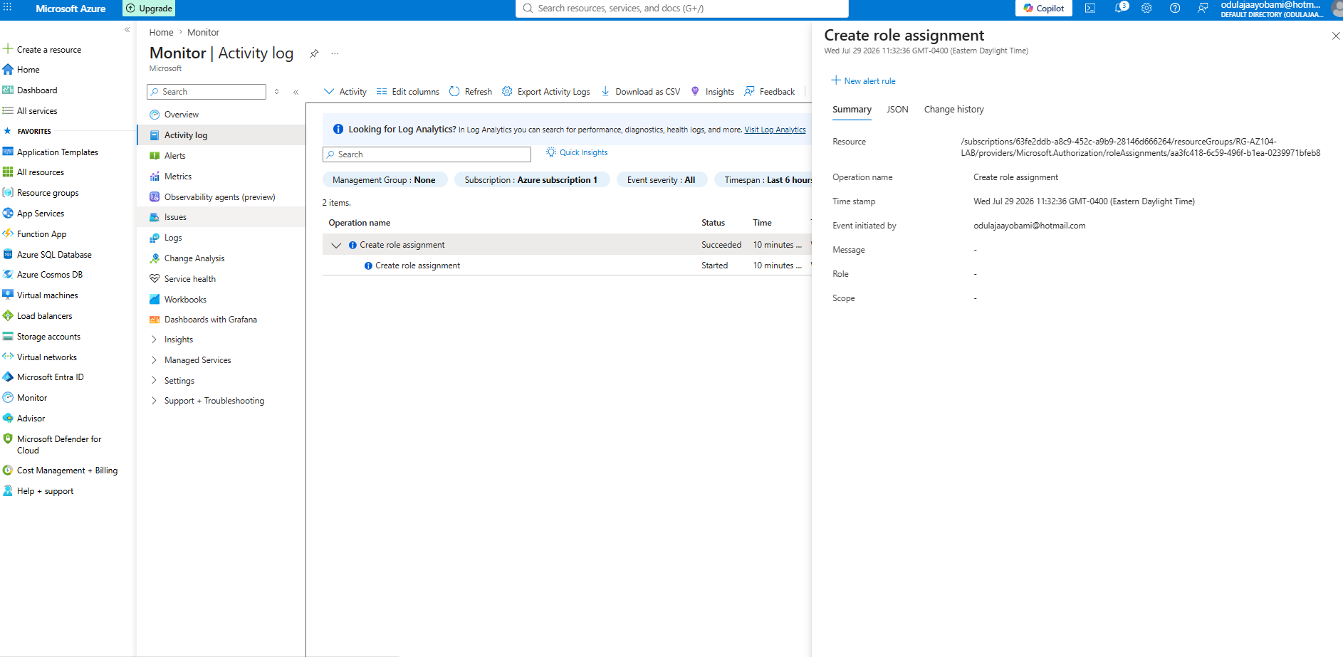

Setting up Password reset by rolling out SSPR

Creating a Security group 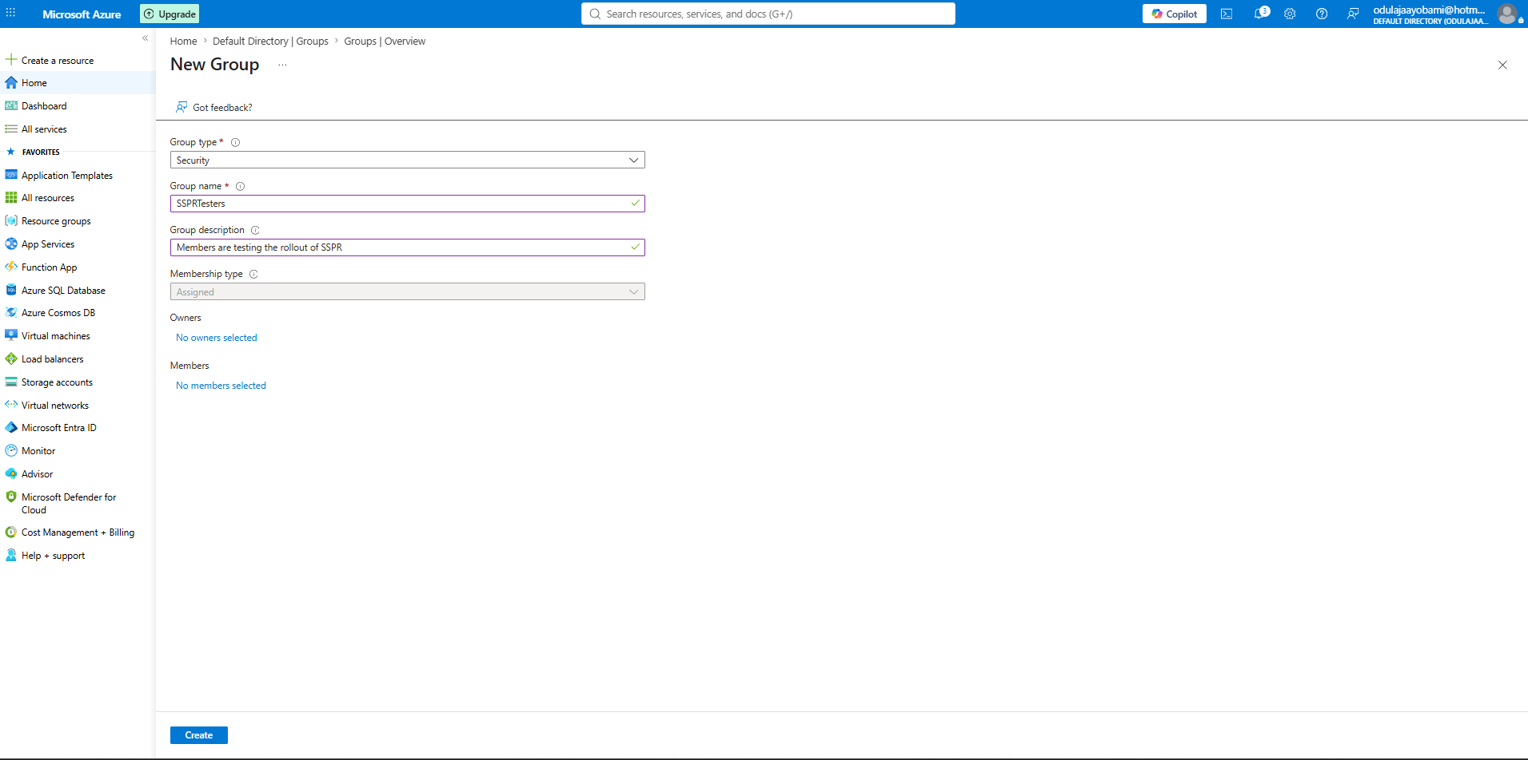

Adding Lab User to SSPRTester 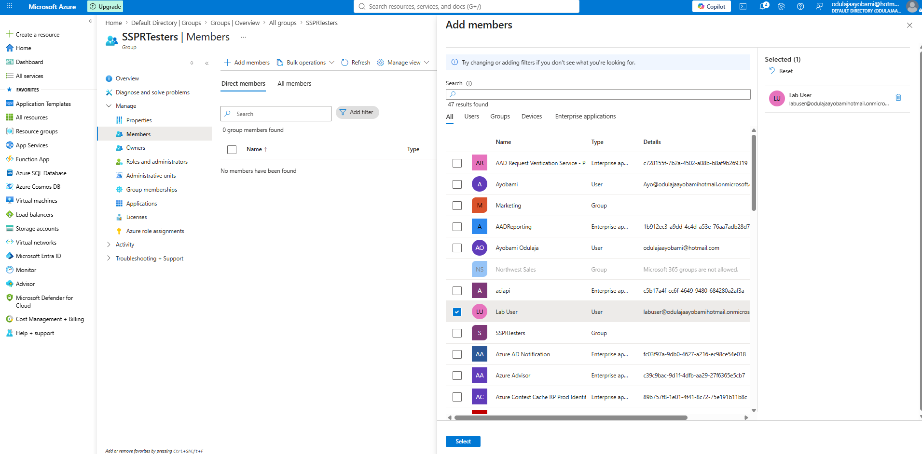

Enabling SSPR 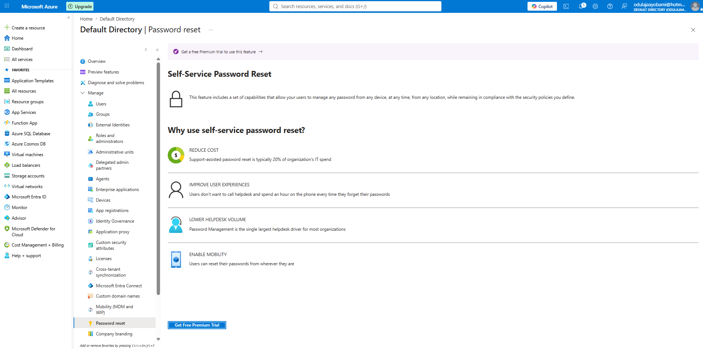

Customize directory branding 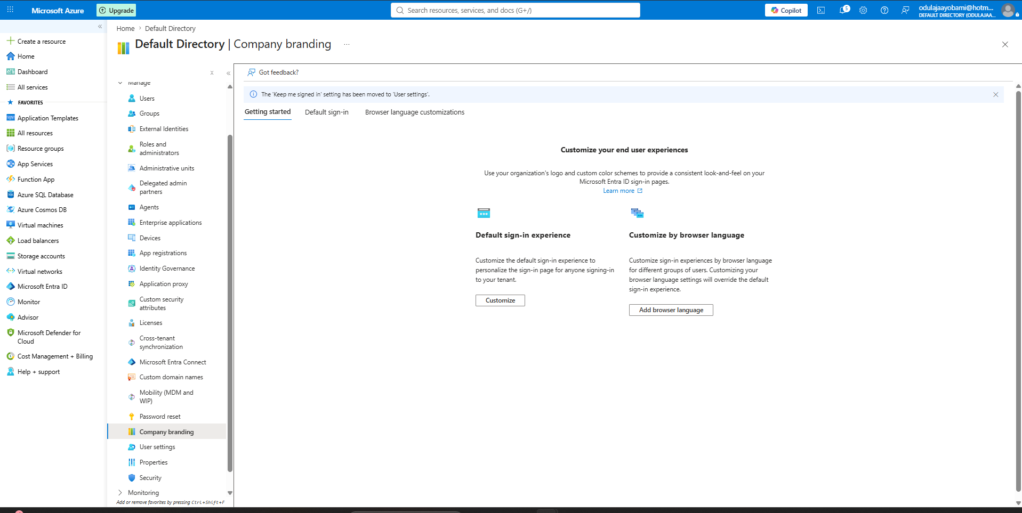 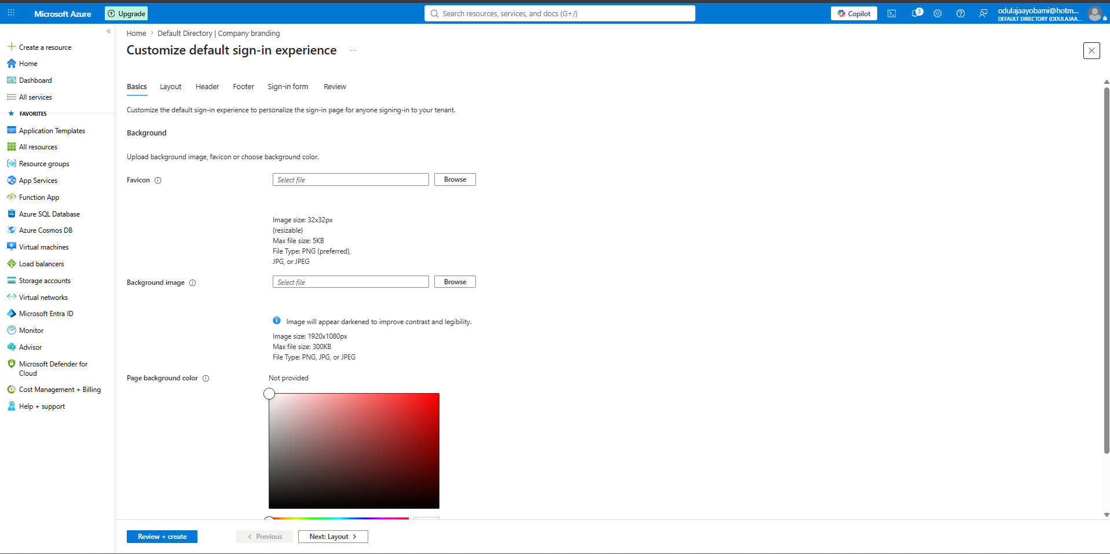

AZURE VIRTUAL NETWORK
Create a Virtual Network 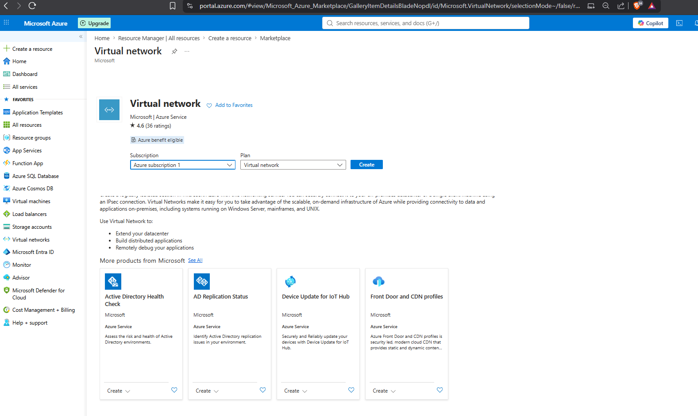 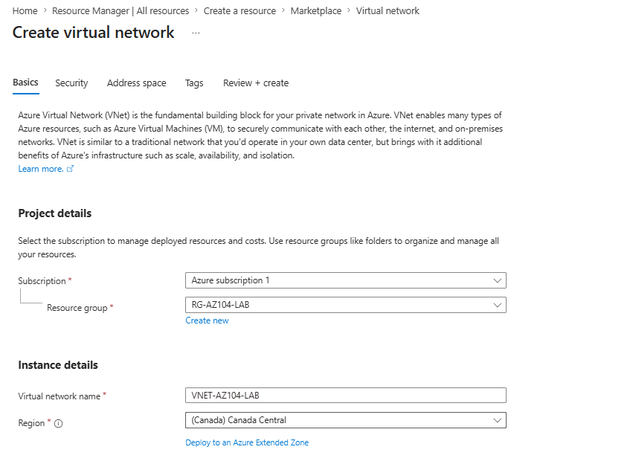 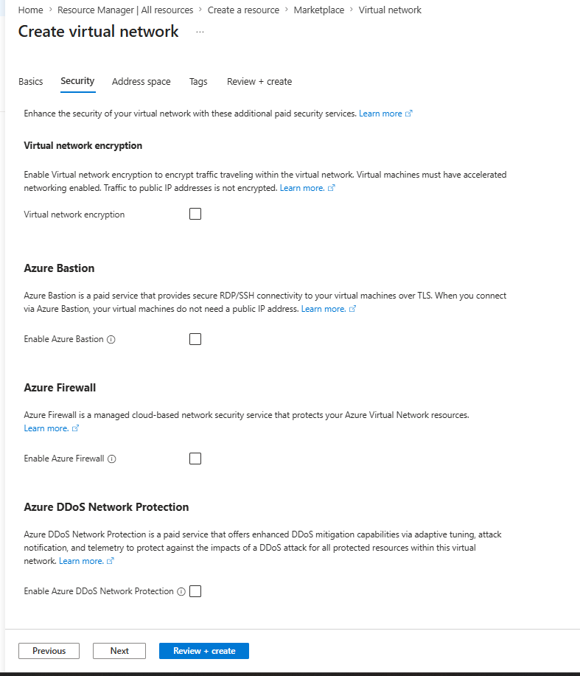 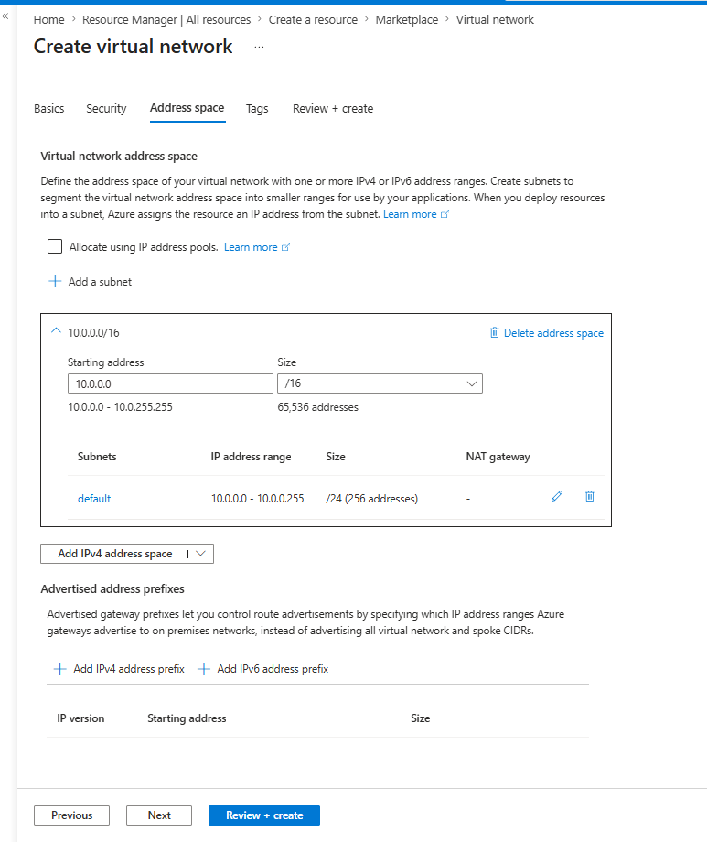 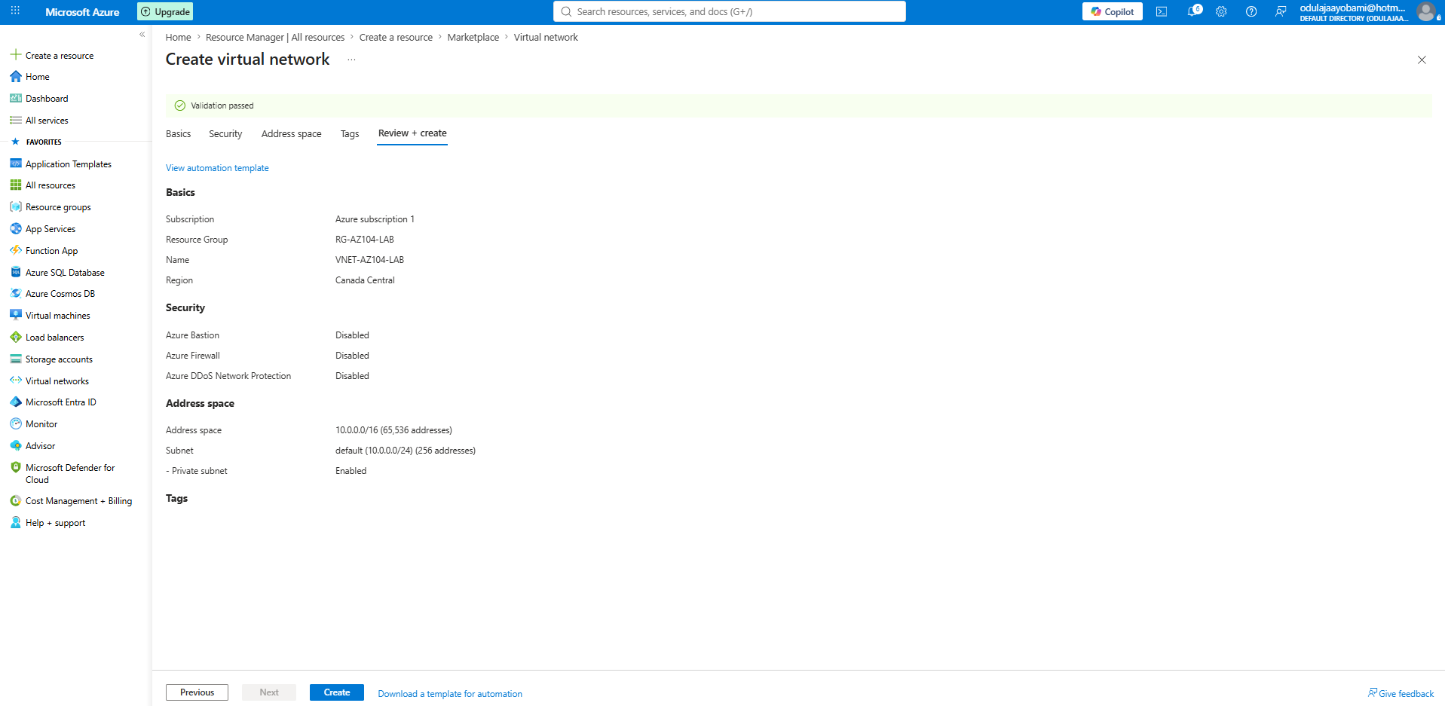 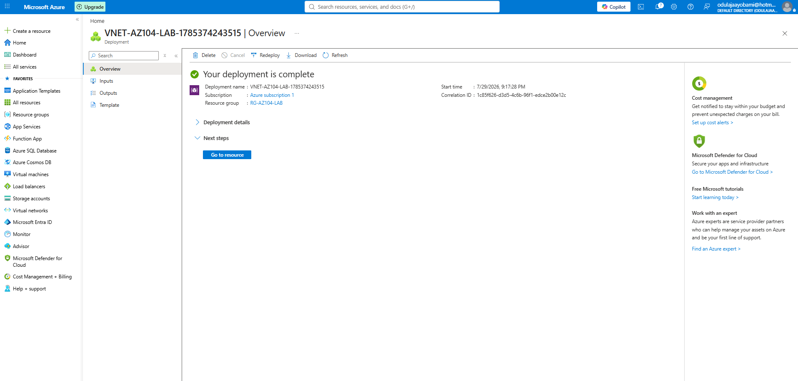

I learned that an Azure Virtual Network (VNet) is the logical foundation for networking in Azure. It provides a private, isolated network where Azure resources such as virtual machines, databases, and storage accounts can communicate securely. Each VNet is assigned a unique CIDR address space, can be divided into subnets for better organization, and can connect securely to other VNets or on-premises networks using VPNs or other connectivity options. Proper planning of address spaces is essential to avoid overlapping IP ranges when connecting networks.

Create and Configure Virtual Networks

My organization is migrating a web-based application to Azure. Your first task is to put in place the virtual networks and subnets. You also need to securely peer the virtual networks. You identify these requirements.
- Two virtual networks are required, app-vnet and hub-vnet. The virtual networks simulate a hub and spoke network architecture.
- The app-vnet hosts the application. The app-vnet virtual network requires two subnets. The frontend subnet hosts the web servers. The backend subnet hosts the database servers.
- The hub-vnet only requires a subnet for the firewall.
- The two virtual networks must be able to communicate with each other securely and privately through virtual network peering.
- Both virtual networks should be in the same region.

Hub-and-Spoke Architecture

Create app-vnet and its subnets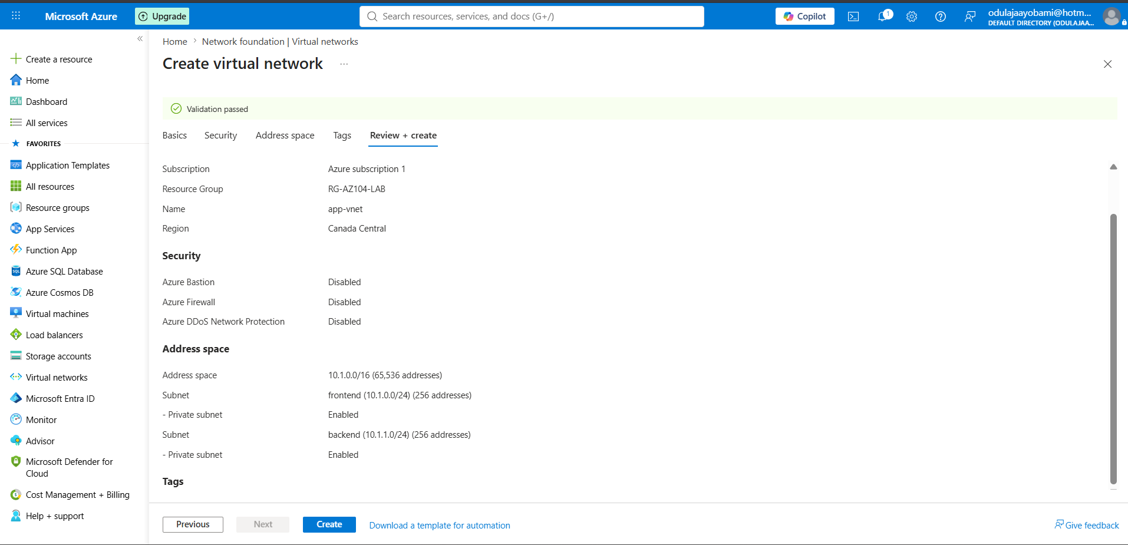

Hub-Vnet and its subnet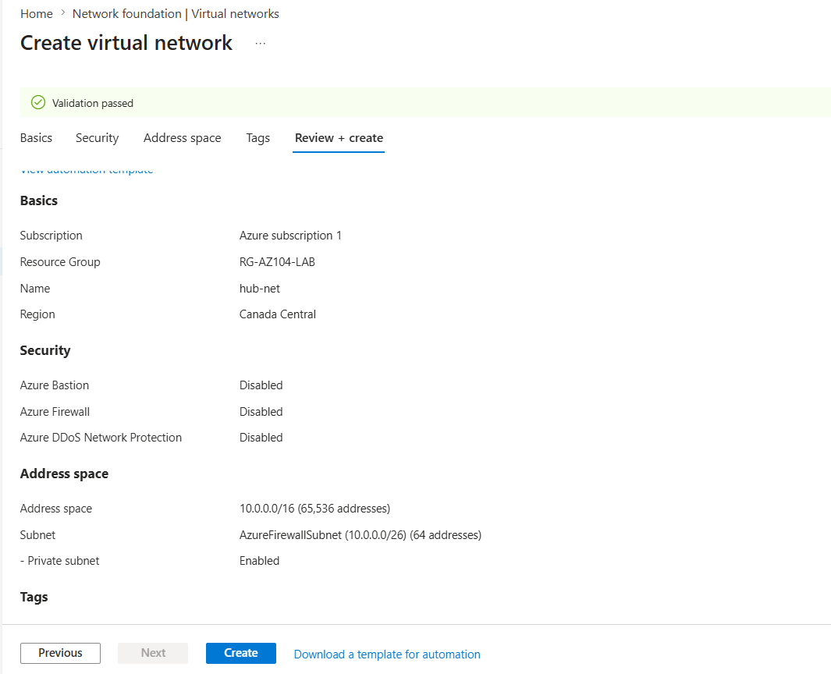

Virtual Networks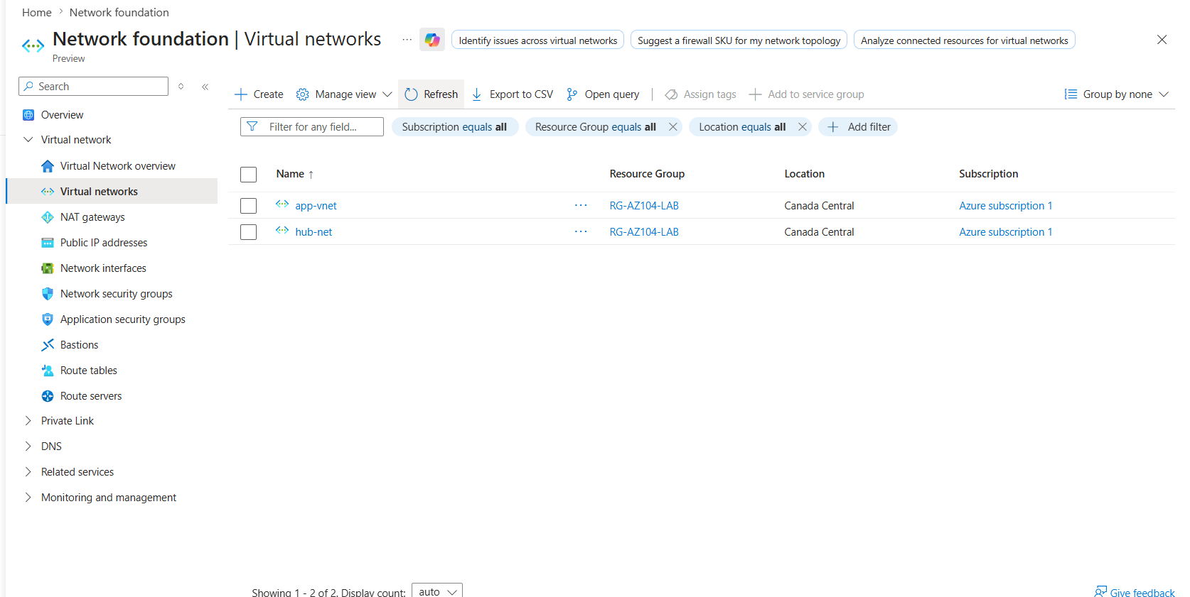

Virtual Peering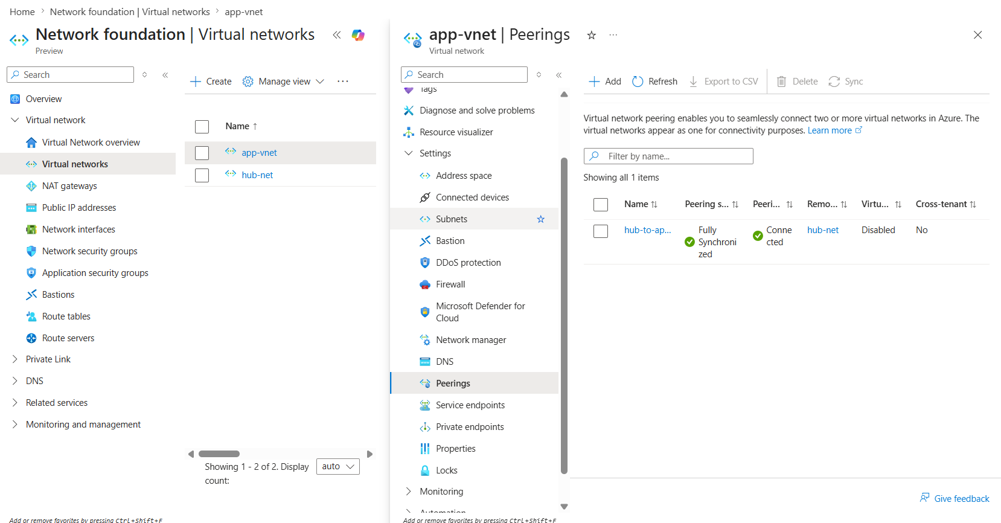

Implementing a Virtual Network

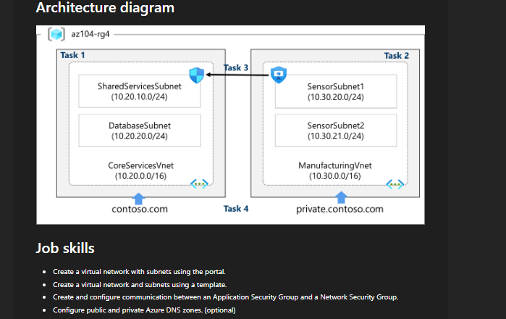

Creating CoreService Vnet and its Subnets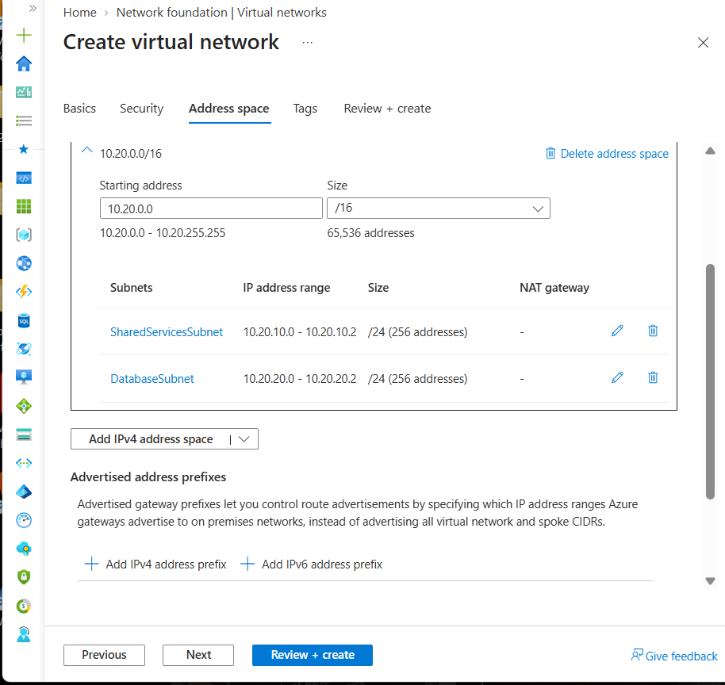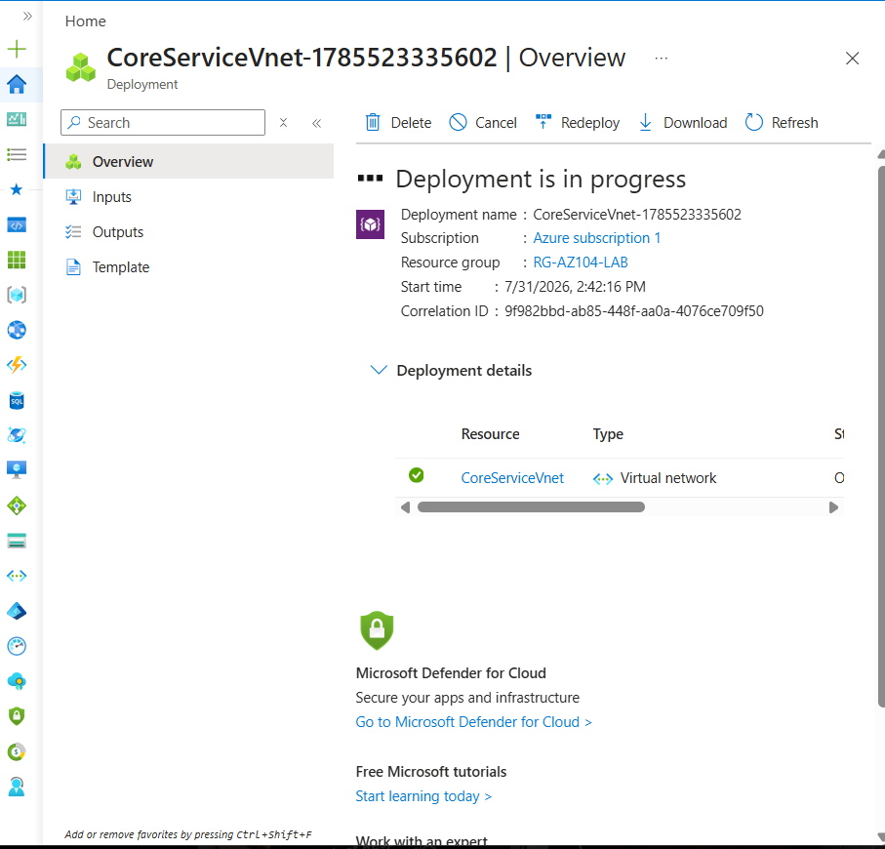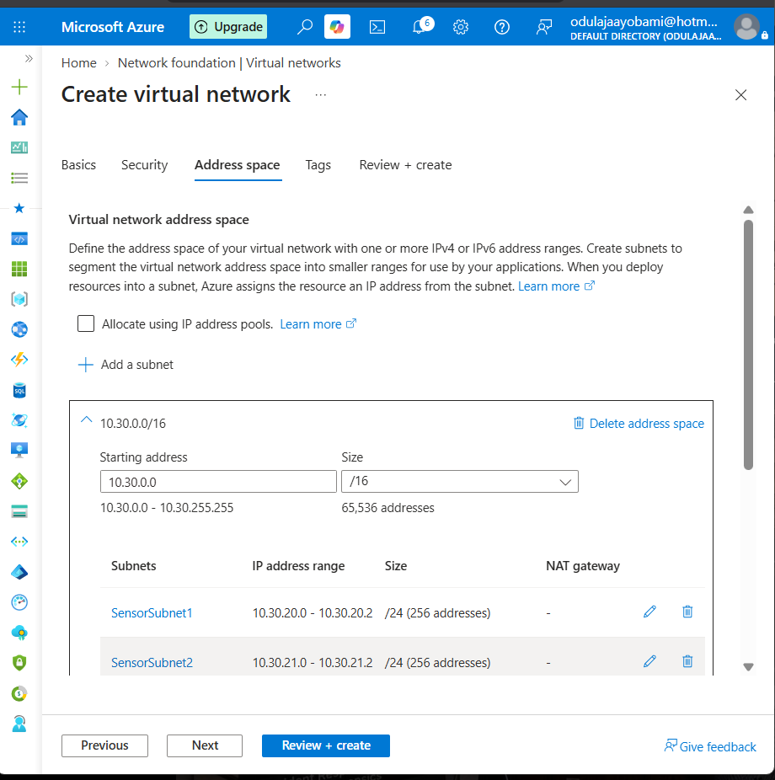
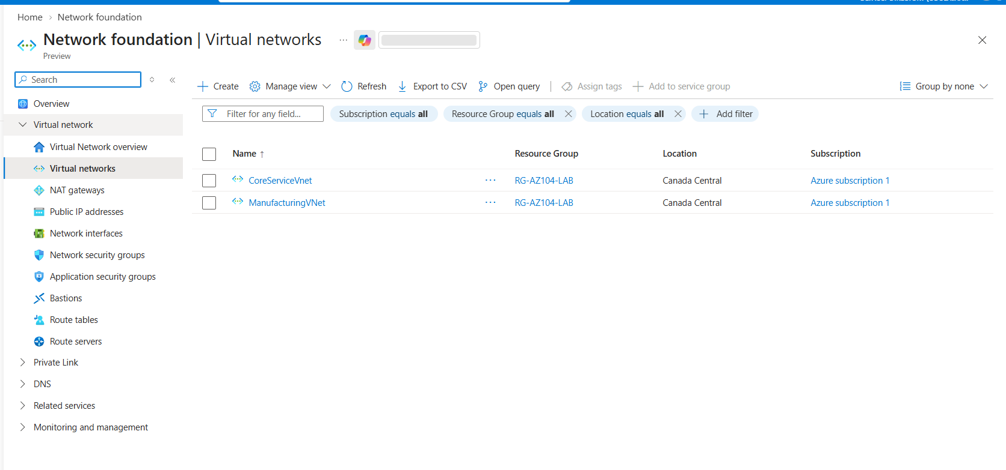

VNET PEERING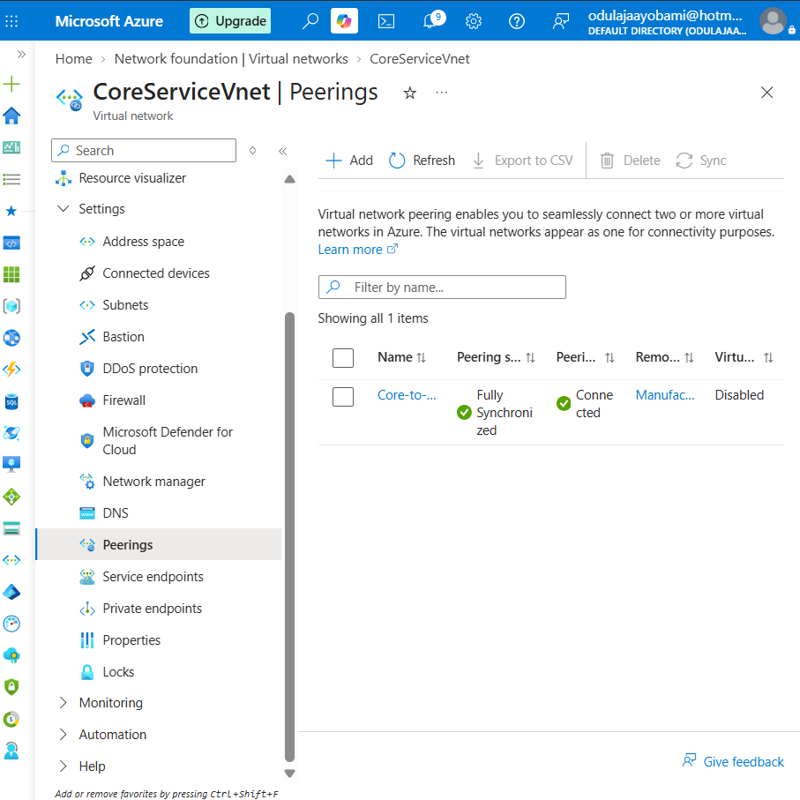

Creating a DNS Zone and DNS Records Using Azure DNS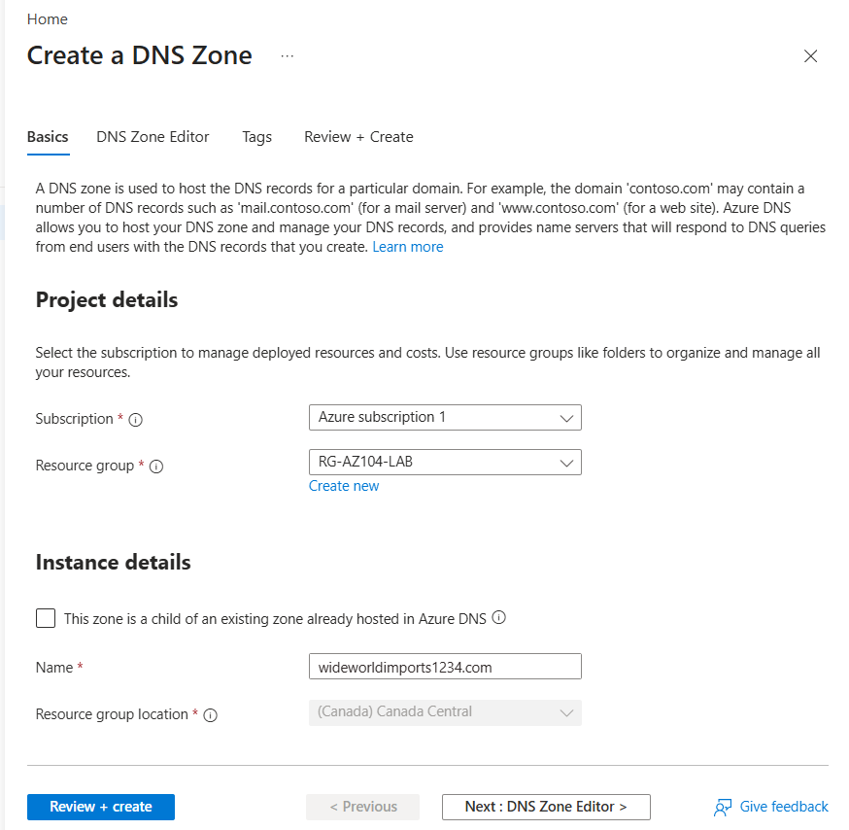
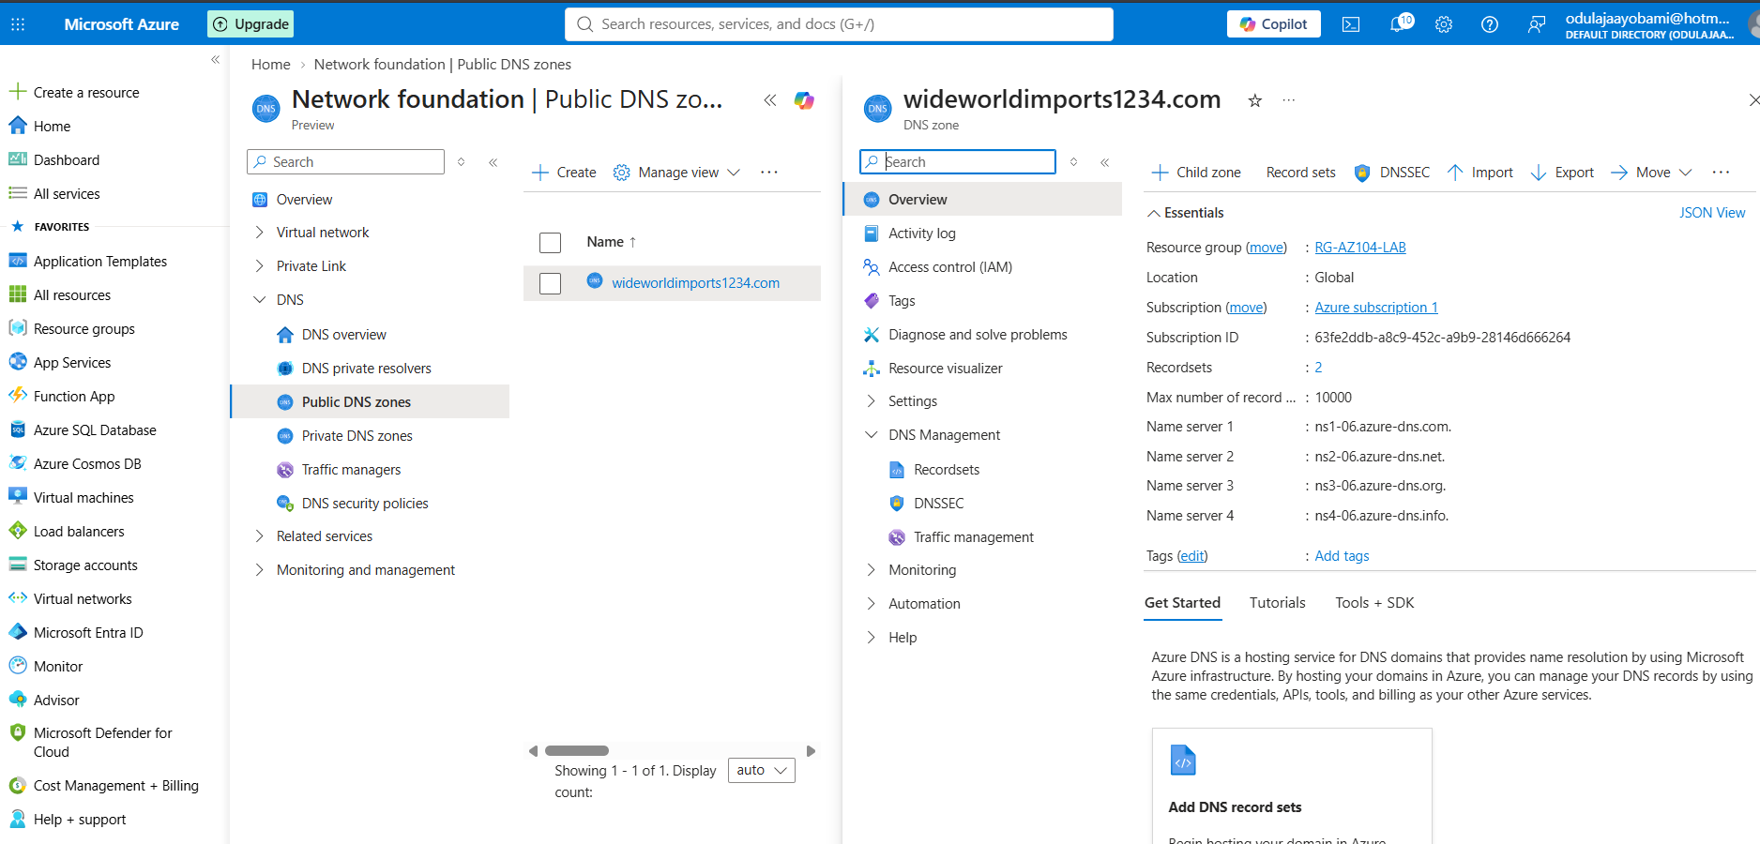

Creating A Record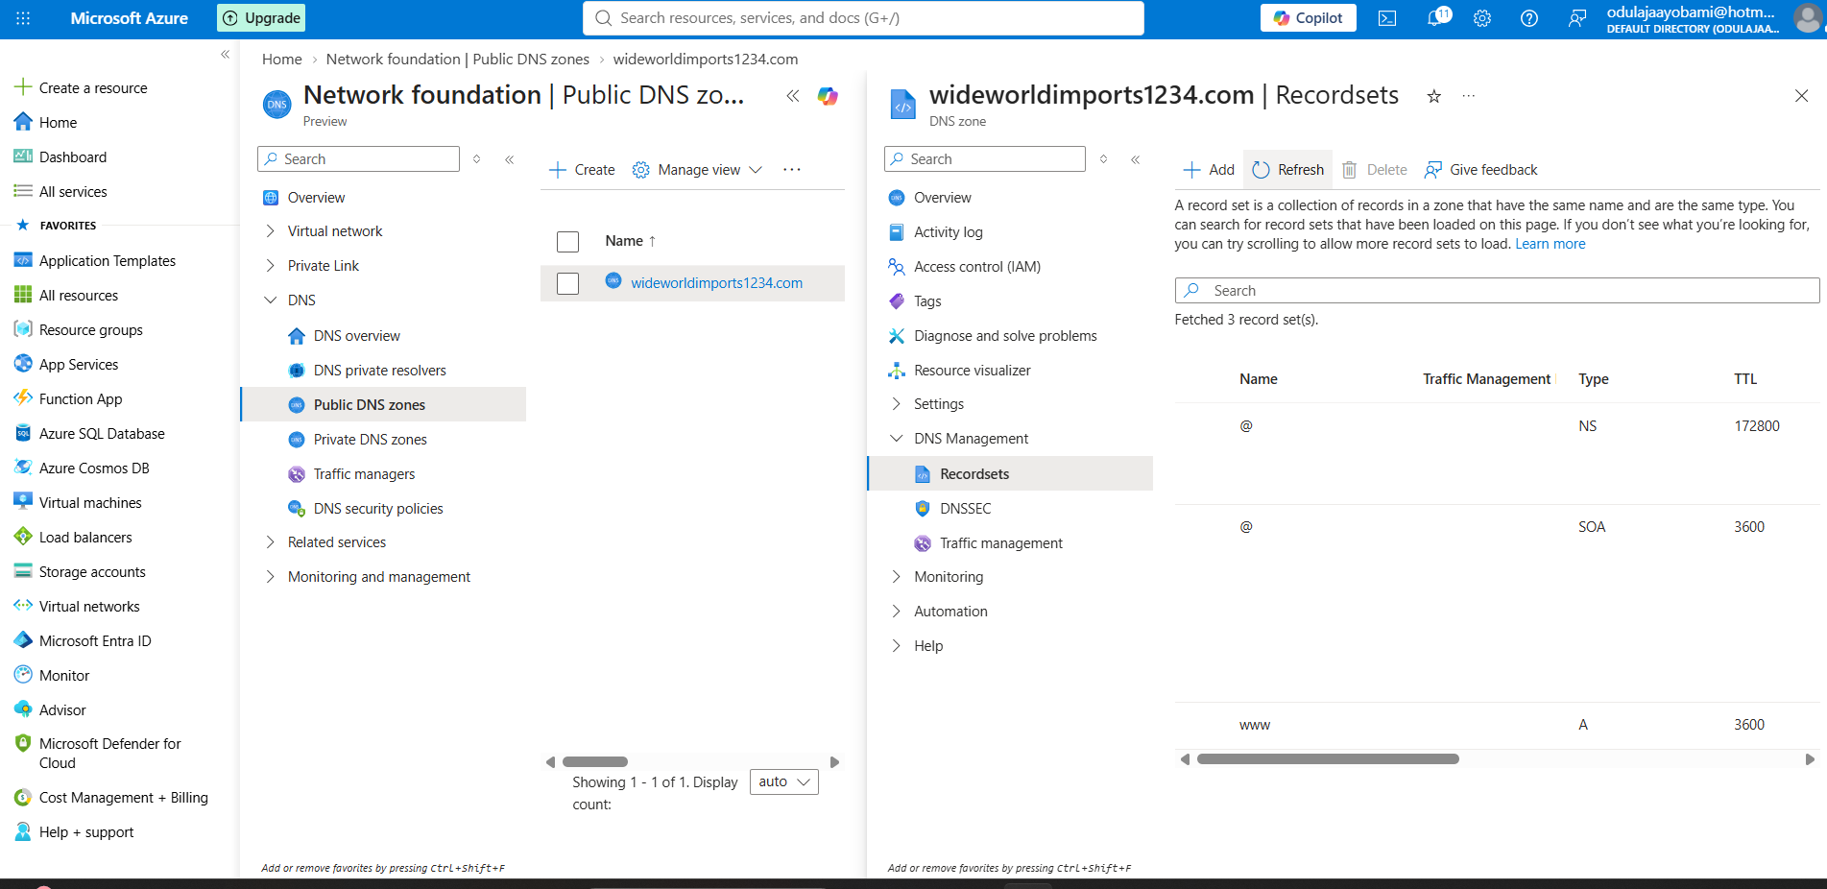

Verifying DNS using nslookup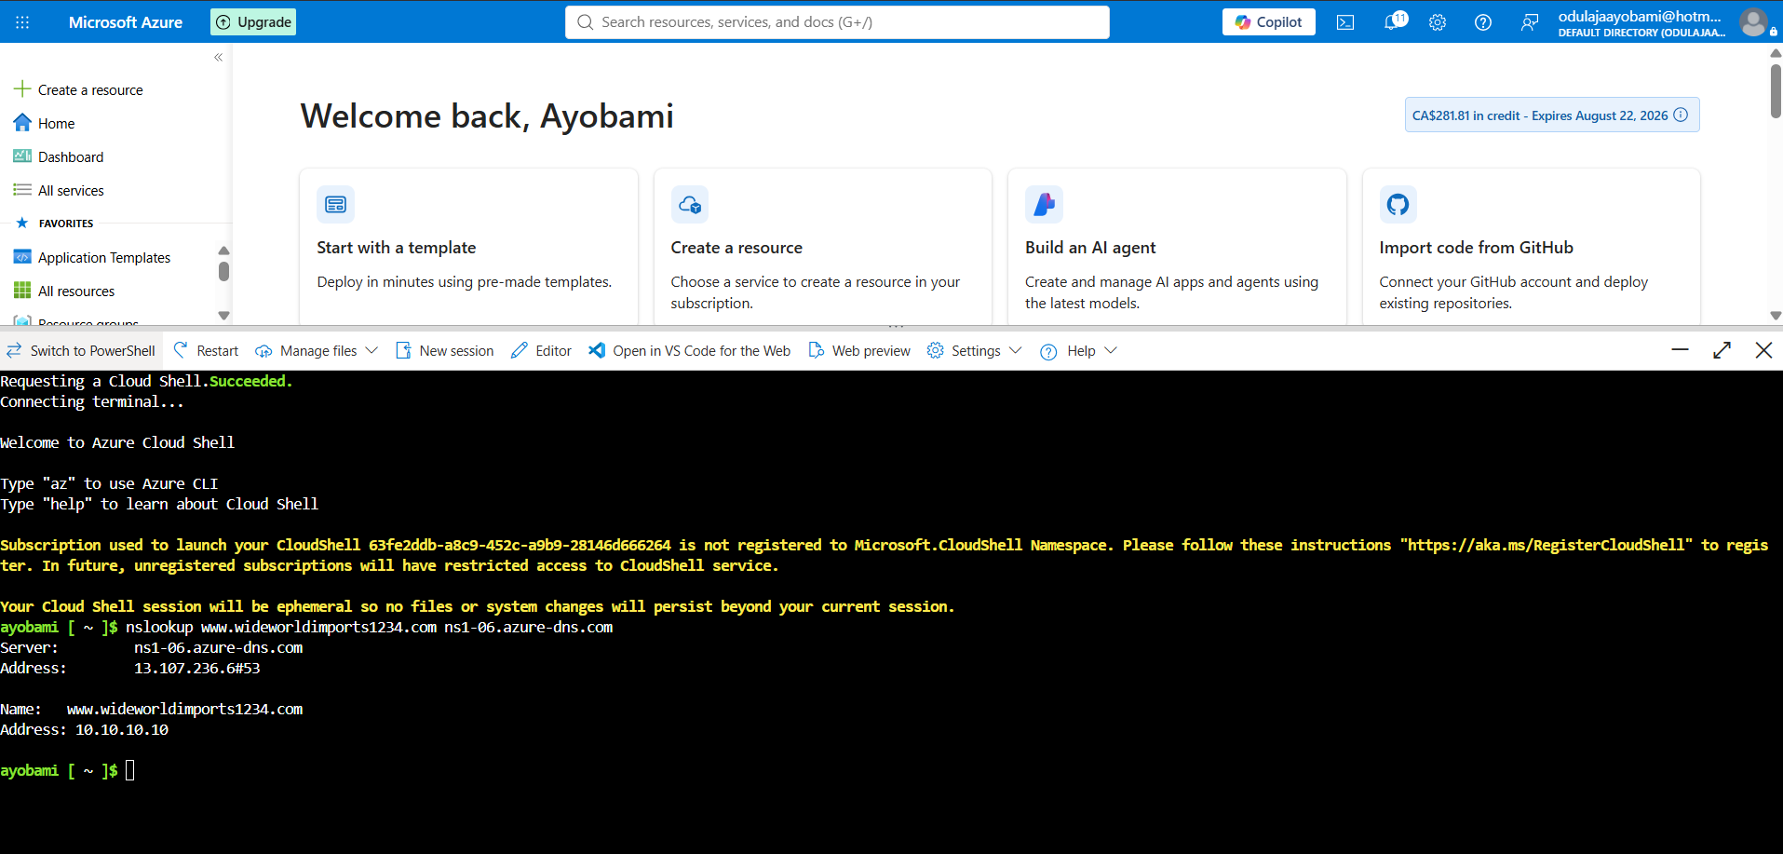

CREATING A CUSTOM ROUTE

First I created a new Resource group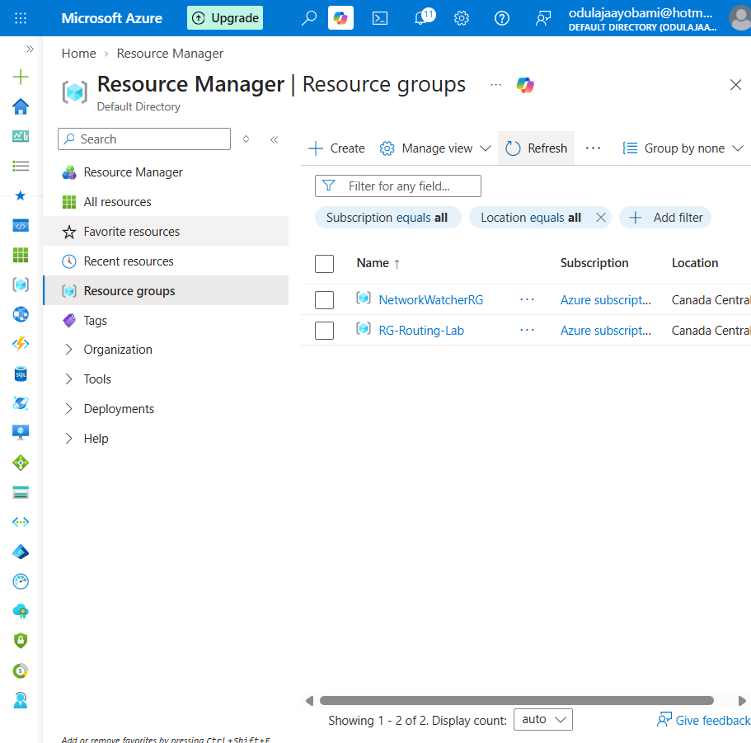

I deployed a new route table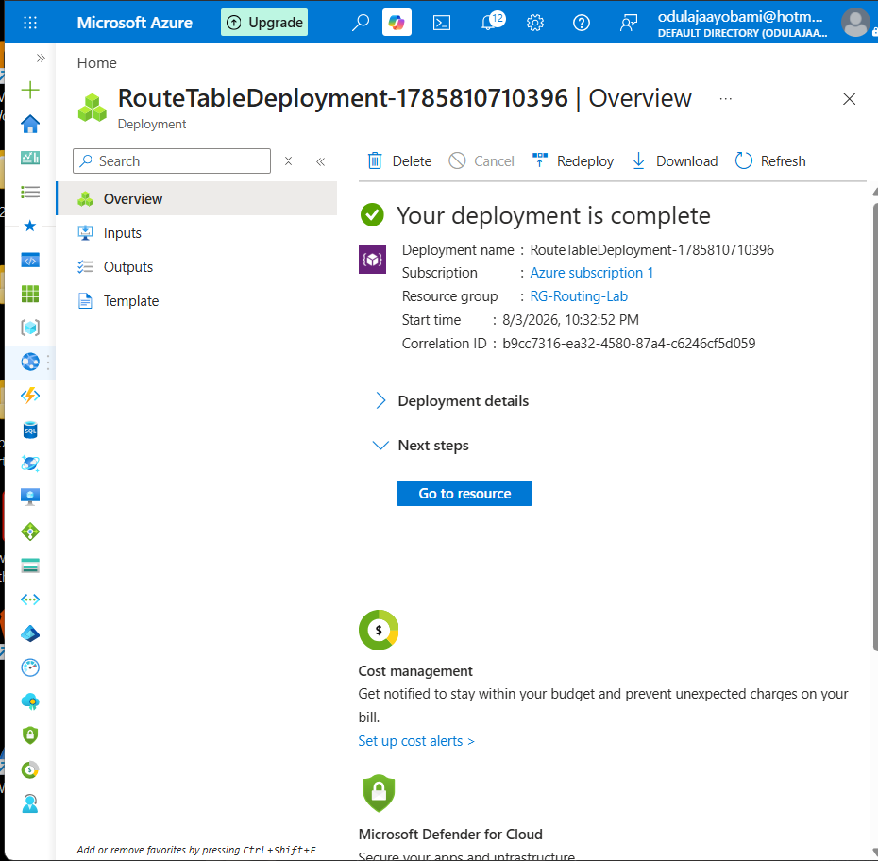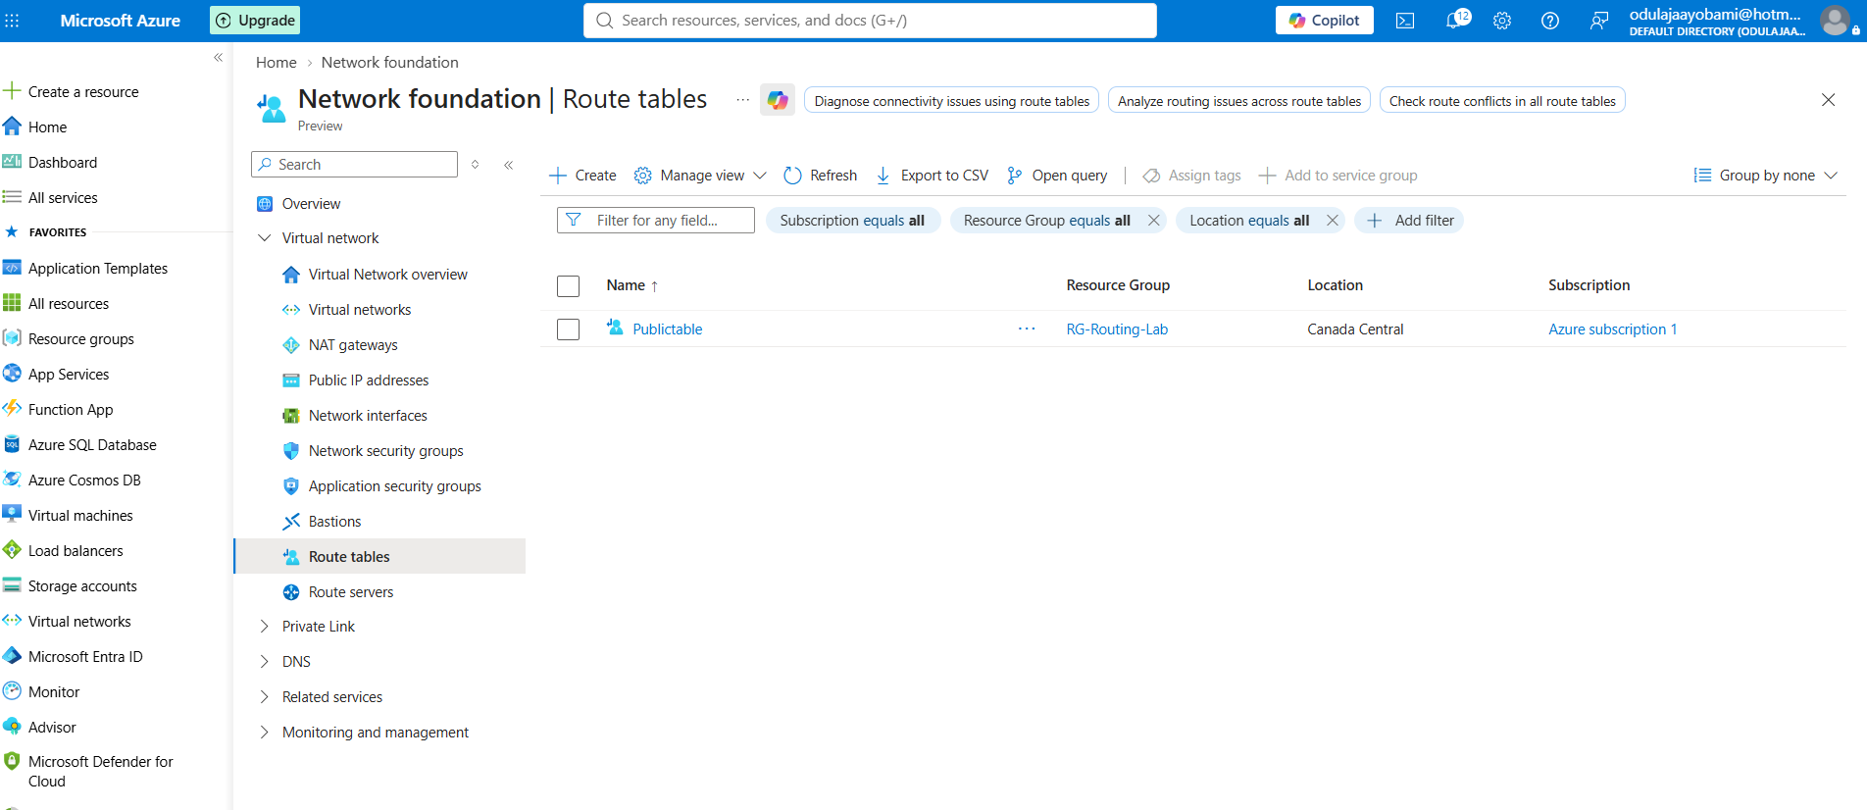

Applying Custom Route to the Routing Table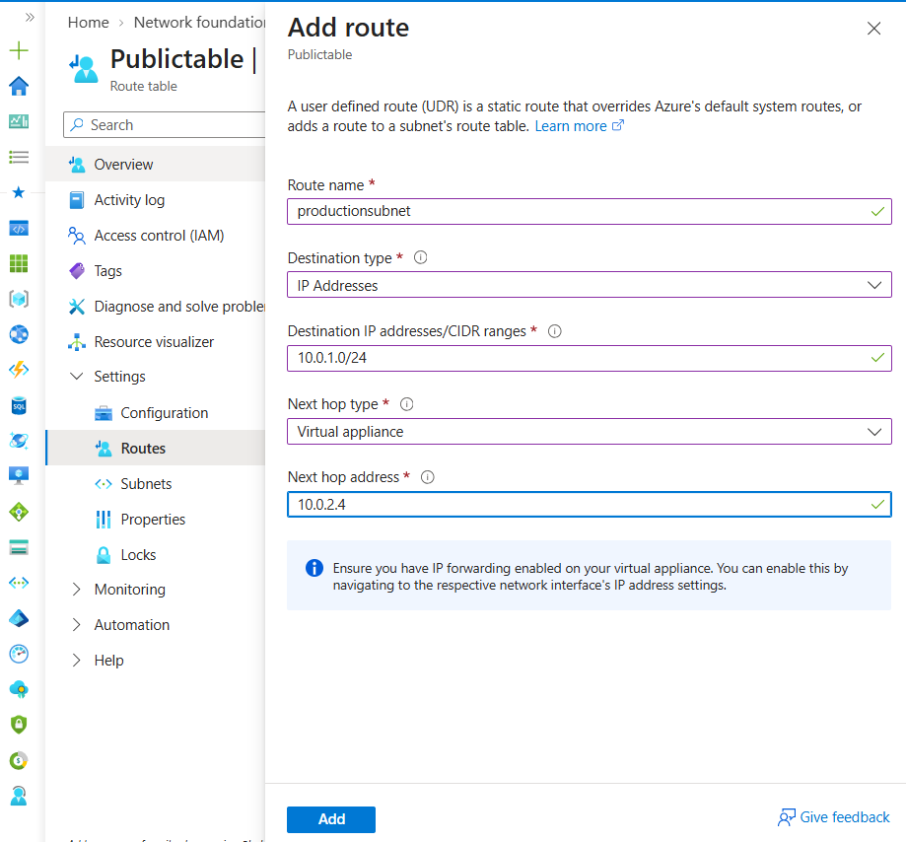

Creating a Virtual network and its Subnets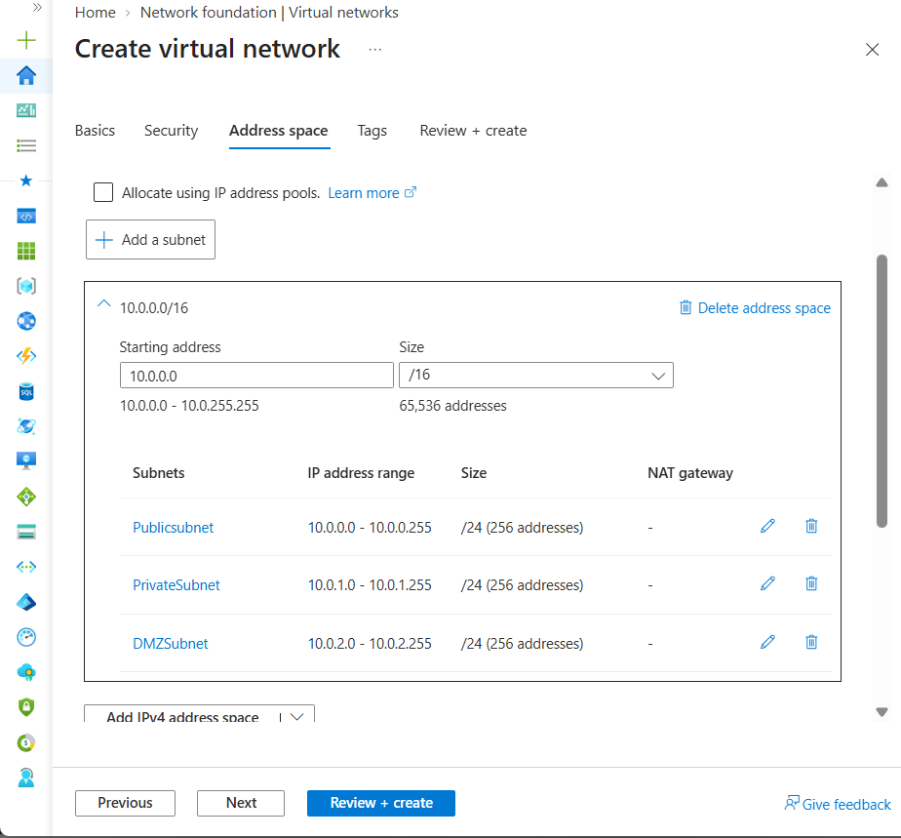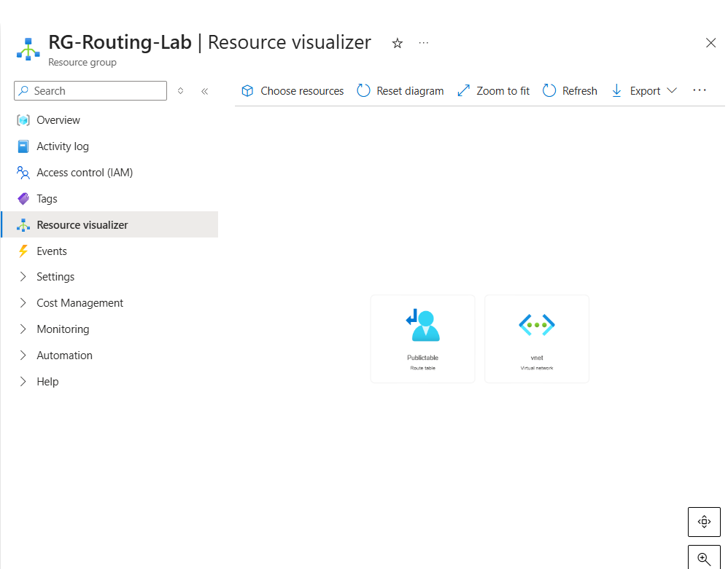

I attached the Route table to the public subnet as seen below